3. Producing Data

Introduction
Chapters 1 and 2 describe methods for exploring data. Such exploratory data analysis is used to determine what the data tell us about the variables measured and their relations to each other. Conclusions apply to the data observed and may not generalize beyond these data. Statistical inference produces answers to specific questions, along with a statement of how confident we are that the answer is correct. Answers are usually intended to apply beyond the data observed. This requires careful production of data appropriate for answering the specific questions asked.

First Steps
Good, high quality data is the key to making good inferences, and learning about a problem. This chapter presents some concepts that will help you recognize good data production systems.
Anecdotal data based on a few isolated cases is usually unreliable. Available data collected for other purposes, such as data produced by government agencies(for example, U.S. Census Bureau http://www.census.gov/ ), can be helpful but again is not always reliable.
Sampling selects a part of population of interest to represent the whole.
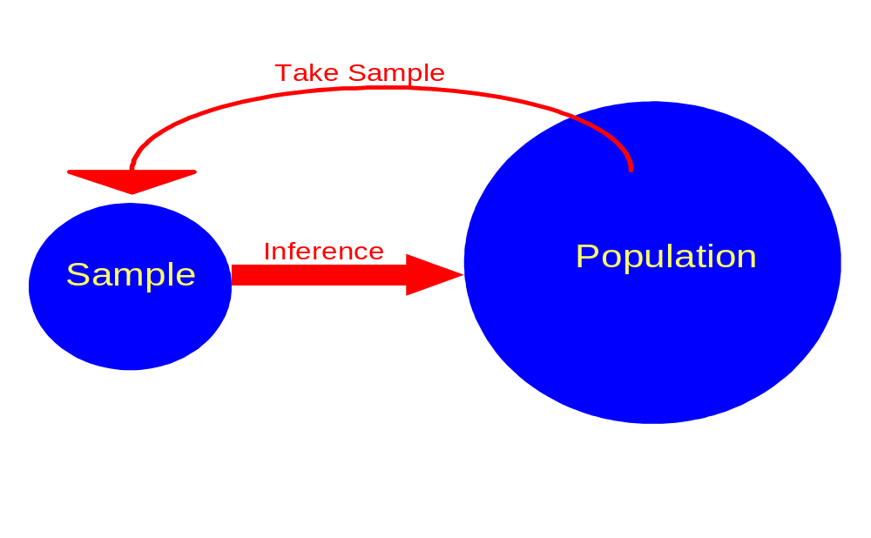Done properly, sampling can yield reliable information about a population.
Two basic types of studies are observational studies and designed experiments. An observational study observes individuals and measures variables of interest and does not attempt to influence the responses. A sample survey is a type of observational study. A designed experiment deliberately imposes some treatment or conditions on individuals to observe their responses. A drug study were some patients get drug A and others get drug B is an example of an experiment. The study investigator imposes which subjects get which drug.
As another example, consider the health effects of second hand smoke(SHS). A study that examines the health effects of those exposed to SHS, and compares with a group not exposed to SHS is an observational study. The subjects sort themselves into the exposure groups. This would be an experiment (unethical) if an investigator randomly assigned some subjects to be exposed to SHS and other subjects not exposed.
When we wish to assess cause and effect relationships, an experiment is the only true way to evaluate the effects of the experimental conditions. Observational studies can shed light, but they tend to not be as convincing as a good designed experiment.

Design of Experiments
A study is an example when we actually do something to people, animals, or objects in order to observe the response. Here is the basic vocabulary of experiments.
Experimental Units, Subjects, Treatment
The individuals on which the experiment is done are the experimental units. When the units are human beings, they are called subjects. A specific experimental condition applied to the units is called a treatment.
Example Does regularly taking aspirin help protect people against heart attack?
The Physicians’ Health Study looked at the effects of two drugs: aspirin and beta carotine.
The subjects were 21,996 male physicians. There were two factors, each having two levels: aspirin (yes or no) and beta carotine (yes or no). Combinations of the levels of these factors form the four treatment shown in Figure 3.1. One-fourth of the subjects were assigned to each of these treatments. So there are four treatments in the experiment.
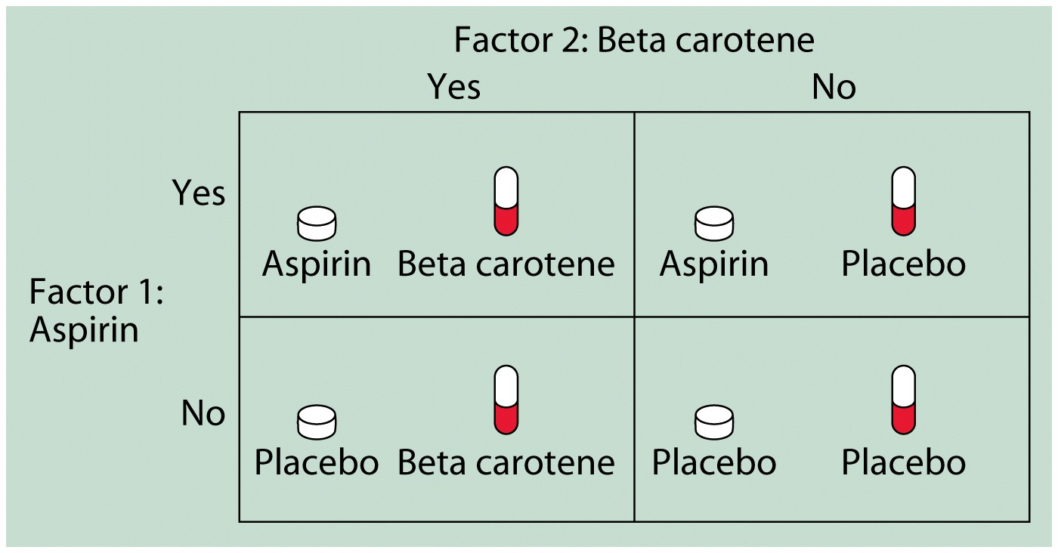
Figure The treatments in the Physicians’ Health Study.
The result shows that 239 of the placebo group but only 139 of the aspirin group had suffered heart attack.

As an example if two different curriculum programs are to be tried in Minnesota high schools, some high schools will use one curriculum and the rest of the schools will use the other program. In this case the experimental units are the high schools, not individual students. The treatments are the two different curriculum programs.

The explanatory variables in an experiment are called factors, and the specific values of these variables are called levels. In a blood pressure experiment where we wish to study the effects of two drugs and diets on blood pressures, there are two factors in this study. The first is the drug (has two levels drug A, drug B), and the other factor is diet (also two levels, Mcdonalds or Burger King). The different combinations, four of them (AM,ABK,BM,BBK) represent the four possible treatments.
Bias
The design of a study is biased if it systematically favors certain outcomes.

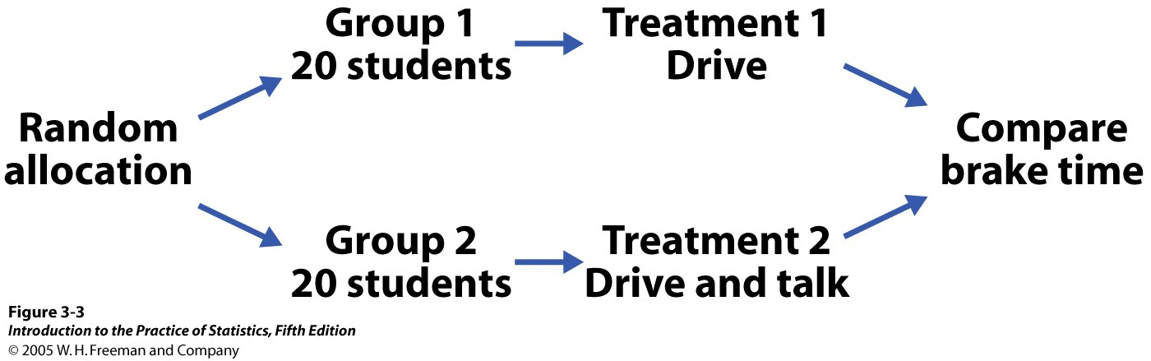
Figure 3.3 Outline of a randomized comparative experiment, for Example 3.6 (Page 202)

Randomized comparative experiments
The logic behind the randomized comparative design in Figure 3.2 is as follows:
- Randomization produces groups of rats that should be similar in all respects before the treatments are applied.
- Comparative design ensures that influences other than the diets operate equally on both groups.
- Therefore, difference in average weight gain must be due either to the diets or to the play of chance in the random assignment of rats to two diets.
Here are three important principles of experimental design that you should be aware of:
- Control the effects of lurking variables on the response, most simply by comparing two or more treatments.
- Randomize. Randomly assigning treatments to experimental units will greatly reduce systematic biases, and also will protect against imbalances in factors related to the response, but are unknown to the investigators at this time. This is a free lunch.
- Replication. Use enough experimental units to reduce chance variation in the results. If I give a new drug to one subject and the subject is cured, is my new drug effective? Who knows? Maybe the subject would have gotten well on their own. Maybe this one cure was a fluke. If the drug was tested on more subjects, we could be more certain of its true effectiveness.
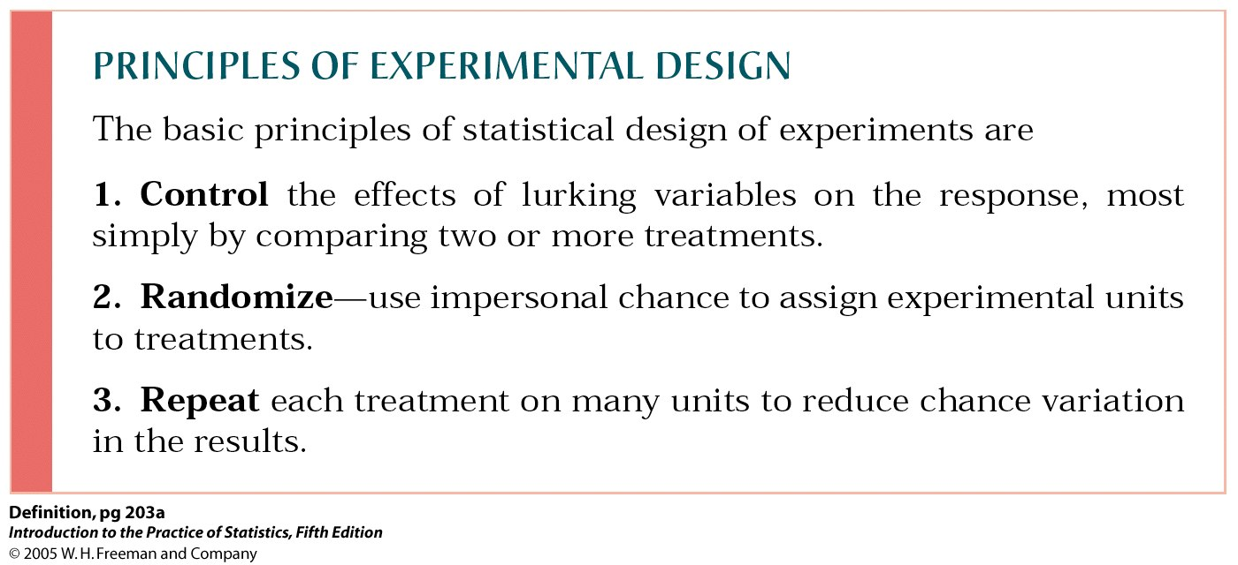

Statistical Significance
An observed effect so large that it would rarely occur by chance is called statistically significant.
The design of a study is biased if it systematically favors certain outcomes.
How to randomize
We use Table B when we need to randomize.
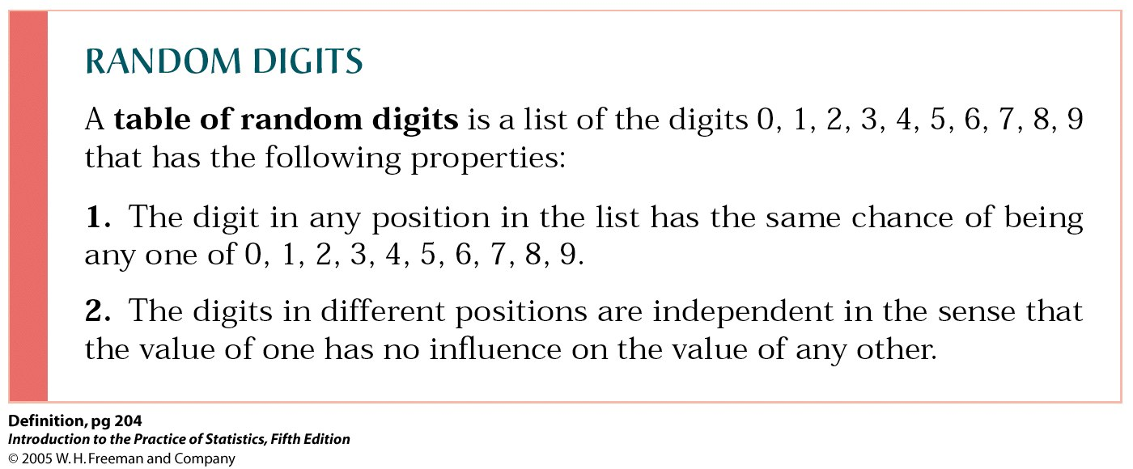

Please look at Example 3.7 at page 204 in our textbook.

Here are some experimental designs that you should know the characteristics for.
- Completely Randomized Design. These designs assign experimental units to treatments with random assignment.
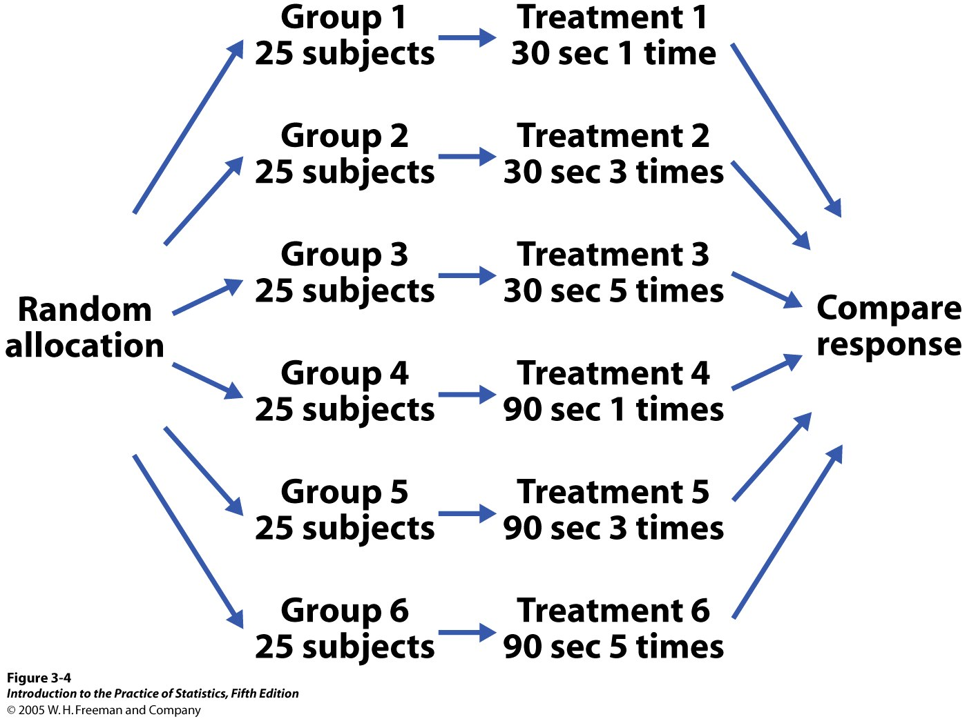
Figure 3.4 Outline of a completely randomized design comparing six treatments, for Example 3.8 (Page 205).

- Block Design. A bolck is a group of experimental units or subjects that are known before the experiment to be similar in some way that is expected to affect the response to the treatments. In a block design, the random assignment of units to treatments is carried out separately within each block.
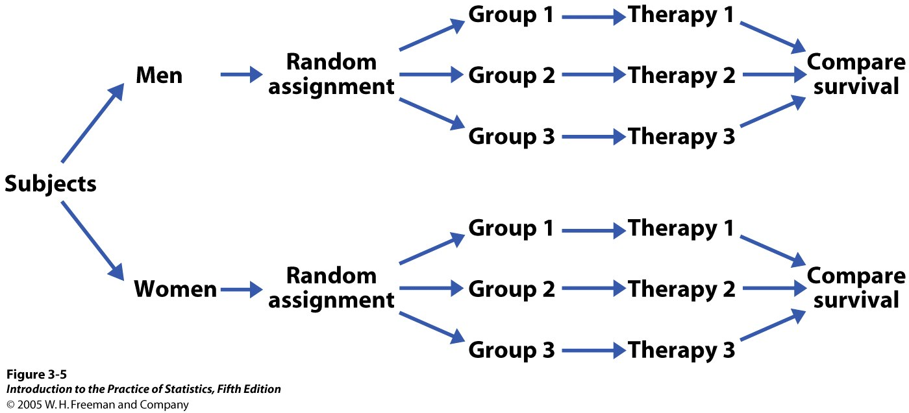

Figure 3.5 Outline of a block design for Example 3.13 (Page 208). The blocks consist of male and female subjects. The treatments are three therapies for cancer.

