Chapter 5. Sampling Distribution.
Introduction
From Chapter3, we learned the definitions of the parameter and statistic:
Parameters and Statistics
A parameter is a number that describes the population. A parameter is a fixed number, but in practice we do not know its value.
A statistic is a number we calculate based on a sample from the population –its value can be computed once we have taken the sample, but its value varies from sample to sample. A statistic is generally used to estimate a population parameter which is a fixed but unknown number that describe the population.
Why do we study Chapter 5 ?
This chapter is concerned with how to learn about the value of a parameter in a population by taking a sample and studying a statistic.
For example, a parameter is an attribute of the population of interest like the proportion of voters in a state that are planning to vote for candidate X in the next election. This proportion is unknown, but suppose we wish to learn about it. This proportion is called a parameter. We then procede by taking a sample, and calculate the proportion of voters in our sample that plan to vote for candidate X. This sample proportion is called a statistic. All statistics are computed from sample values. How does the sample statistic tell us about the population parameter? That is what this chapter is for.

5.1 Sampling Distribution for counts and Proportions

The Binomial distributions for sample counts

Think of tossing a coin n times as an example of the binomial setting. Each toss gives either heads or tails. The outcomes of successive tosses are independent. If we call heads a success, then p is the probability of obtaining a head. The number of heads we count is a random variable X. The distribution of X is determined by the number of observations n and the succes probability p.

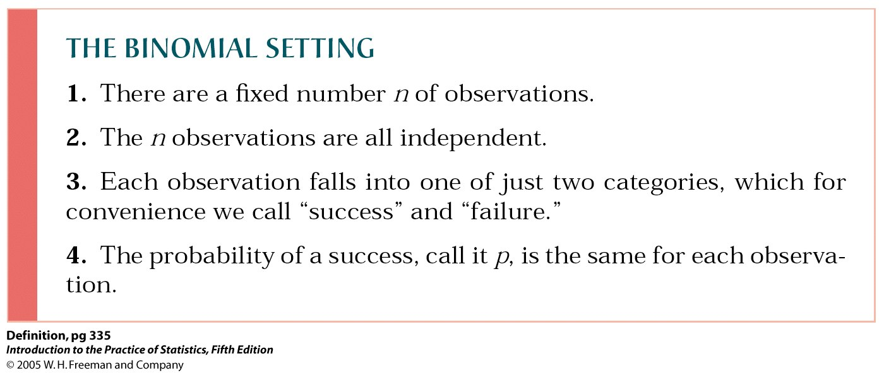
Binomial Distributions
The distribution of the count X of successes is called the binomial distribution with parameters n and p. The parameter n is the number of observations, and p is the probability of a success on any one observation. The possible values of X are the whole numbers from 0 to n. As an abbreviation, we say that X is B(n,p).
Example (a) Toss a balanced coin 10 times and count the number X of heads. There are n=10 tosses. Successive tosses are independent. If the coin is balanced, the probability of a head is p=0.5 on each toss. The number of heads we observe has the binomial distribution B(10, 0.5).

Finding binomial probabilities: Tables
We can find binomail probabilities for some values for n and p by looking up probabilities in Table C in the back of the book. The entries in the table are the probabilities P(X=k) of individual outcomes for a binomial random variable X.
Example A quality engineer selects an SRS of 10 switches from a large shipment for detailed inspection. Unknown to the engineer, 10% of the switches in the shipment fail to meet the specifications. What is the probability that no more than 1 of the 10 switches in the sample fails inspection?
(Solution). Let X = the count of bad switches in the sample.
The probability that the switches in the shipment fail to meet the specification is p = 0.1 and sample size is n=10. Thus, X is B(n=10, p=0.1).
We want to calculate
Let’s look at page T-9 in the Table C for this calcualtion, look opposite n=10 and under p=0.10. This part of the table appears at the left. The entry opposite each k is 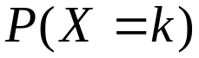. We find
.
About 74% of all samples will contain no more than 1 bad switch.

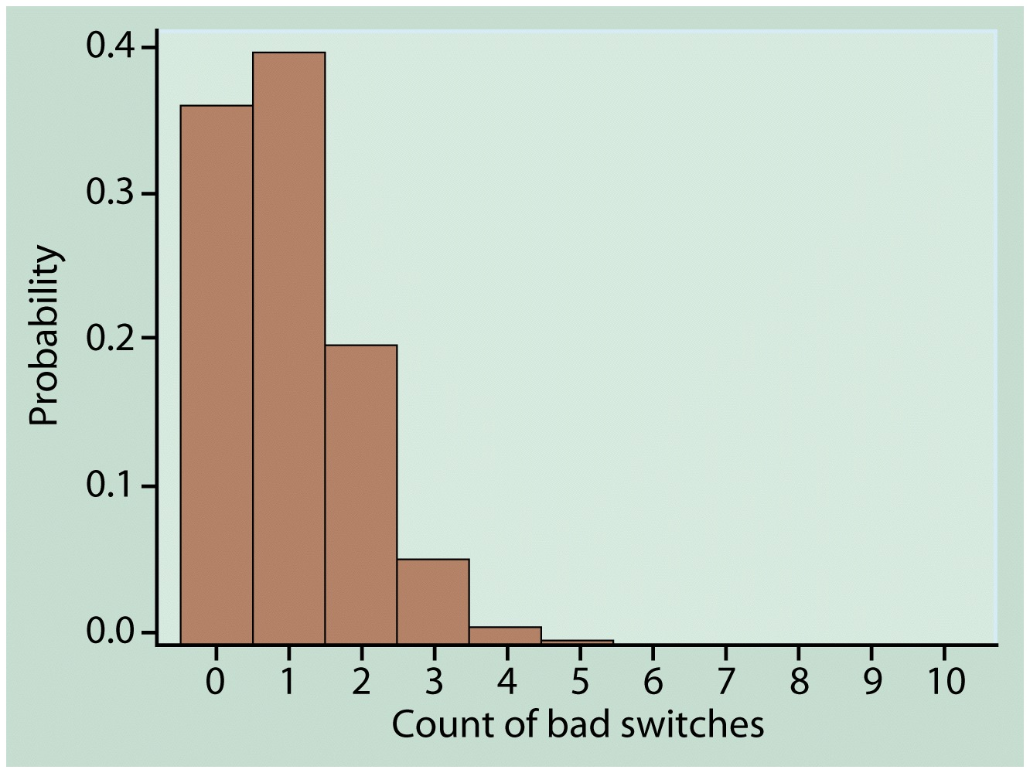

Figure Probability histogram for the binomial distribution with n=10 and p=0.1.

Example 5.6 Corinne is a basketball player who makes 75% of her free throws over the course of a season. In a key game, Corinne shoots 12 free throws and misses 5 of them. The fans think that she failed because she was nervous. Is it unusual for Corinne to perform this poorly?
(Solution). Because the probability of making a free throw is greater than 0.5, we count misses in order to use Table C.
Let X = the number of misses in 12 attempts.
The probability of a miss is p=1-0.75=0.25. Thus, X is B(n=12, p=0.25).
We want the probability of missing 5 or more. This is
.
Let’s look at page T-9 in the Table C for this calcualtion, look opposite n=12 and under p=0.25. This part of the table appears at the left. The entry opposite each k is . We find
.
Corinne will miss 5 or more out of 12 free throws about 16% of the time, or roughly one of every six games. While below her average level, this perfomance is well within the range of the usual chance variation in her shooting.

Binomial Mean and Standard Deviation
If a count X has the binomial distribution B(n,p), then
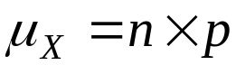
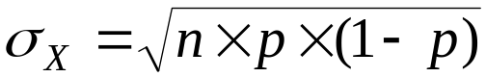

Example 5.7 The Helsinki study planned to give gemfibrozil to about 2000 men aged 40 to 55 and a placebo to another 2000. The probability of a heartattack during the five year period of the study for men this age is about 0.04. What are the mean and standard deviation of the number of heart attacks that will be observed in one group if the treatment does not change this probability?
(Solution). There are 2000 independent observations, each having probability p=0.04 of a heart attack. The count X of heart attacks is B(2000, 0.04), so that
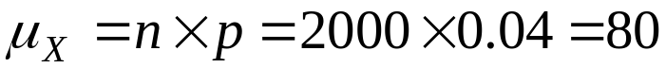
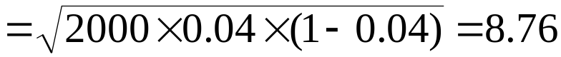

Sample Proportions
A sample proportion is defined as 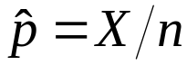 where X is a binomial random variable or the number of subjects with the attribute in the sample and n is the number of subjects in the sample. We wish to learn about the proportion p in the population. We do it through the sampling distribution of the sample proportion.
Statistical theory tells us that if we repeatedly take samples of size n, (where n is fairly large), from our population and from each of the samples calculate , a histogram of these p-hats has three properties:
- The histogram will have approximately a normal shape.
- The center or mean of the distribution will be
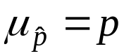.
- The spread or standard deviation of the distribution will be,
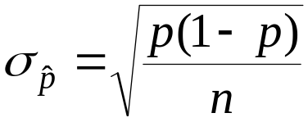.

Example 5.9 The mean and standard deviation of the proportion (60%) of the survey respondents (2500 people) who find shopping frustrating are
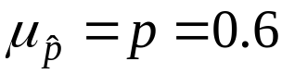.
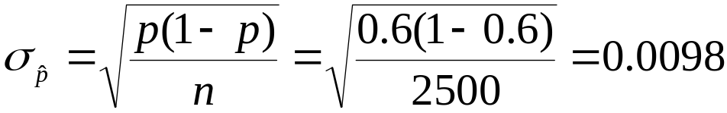.
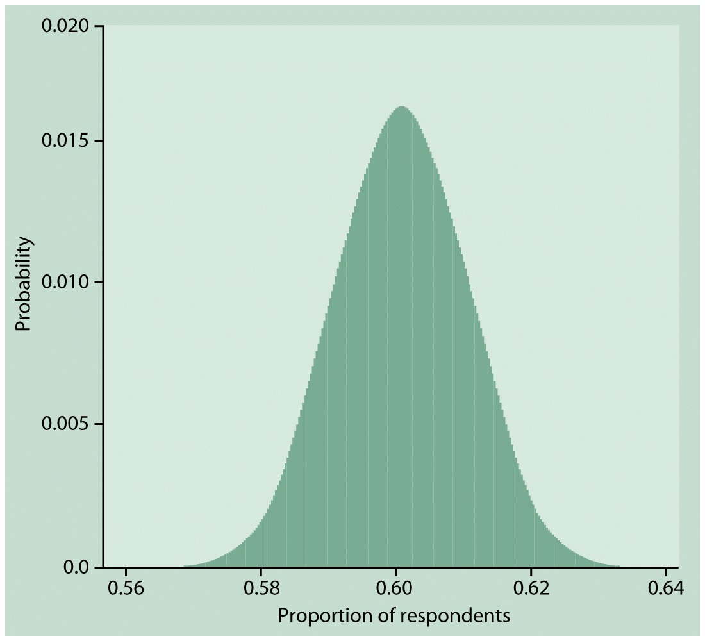
Figure 5.3 Probability histogram of the sample proportion 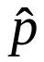 based on a binomial count with 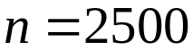 and 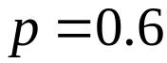. The distribution is very close to normal.
Normal Approximation for Counts and Proportions
Draw an SRS of size n from a large population having population proportion 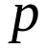 of successes. Let X be the count of successes in the sample and sample proportion of successes. When n is large, the sampling distributions of these statistics are approximately normal:
X is approximately N(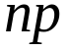,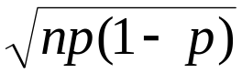)
is approximately N(,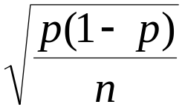).
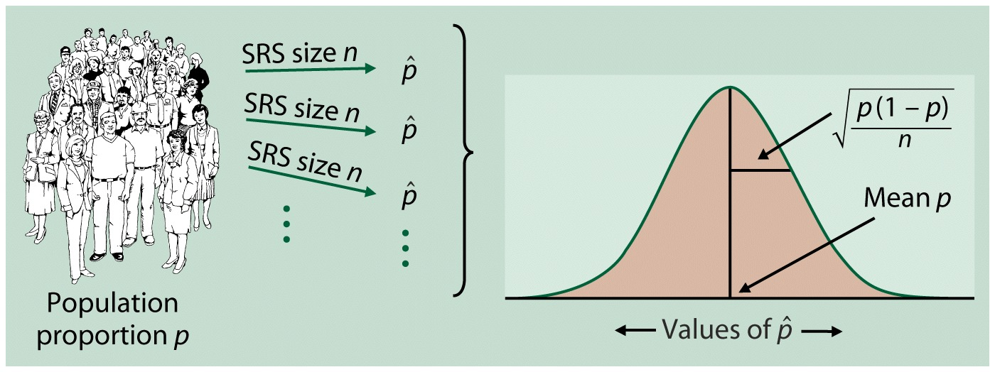
Figure 5.4 The sampling distribution of a sample proportion is approximately normal with mean and standard deviation .
Example 5.10 Let’s compare the normal approximation for the calculation of Example 5.8 with the exact calculation from software. We want to calculate 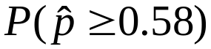 when the sample size is and the population proportion is . Example 5.9 shows that
.
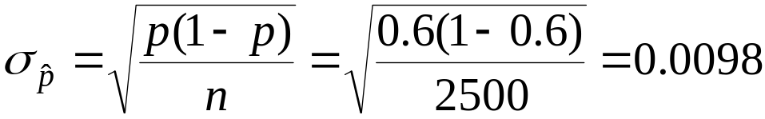.
Act as if were normal with mean 0.6 and standard deviation 0.0098. The approximate probability, as illustrated in Figure 5.4, is
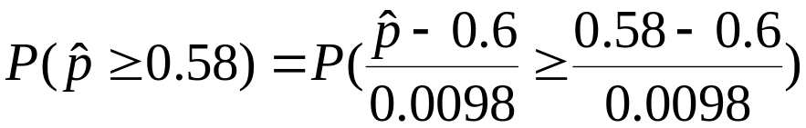
.
That is, about 98% of all samples have a sample proportion that is at least 0.58. Because the sample was large, this normal approximation is quite accurate. It misses the software value 0.9802 by only 0.0009.

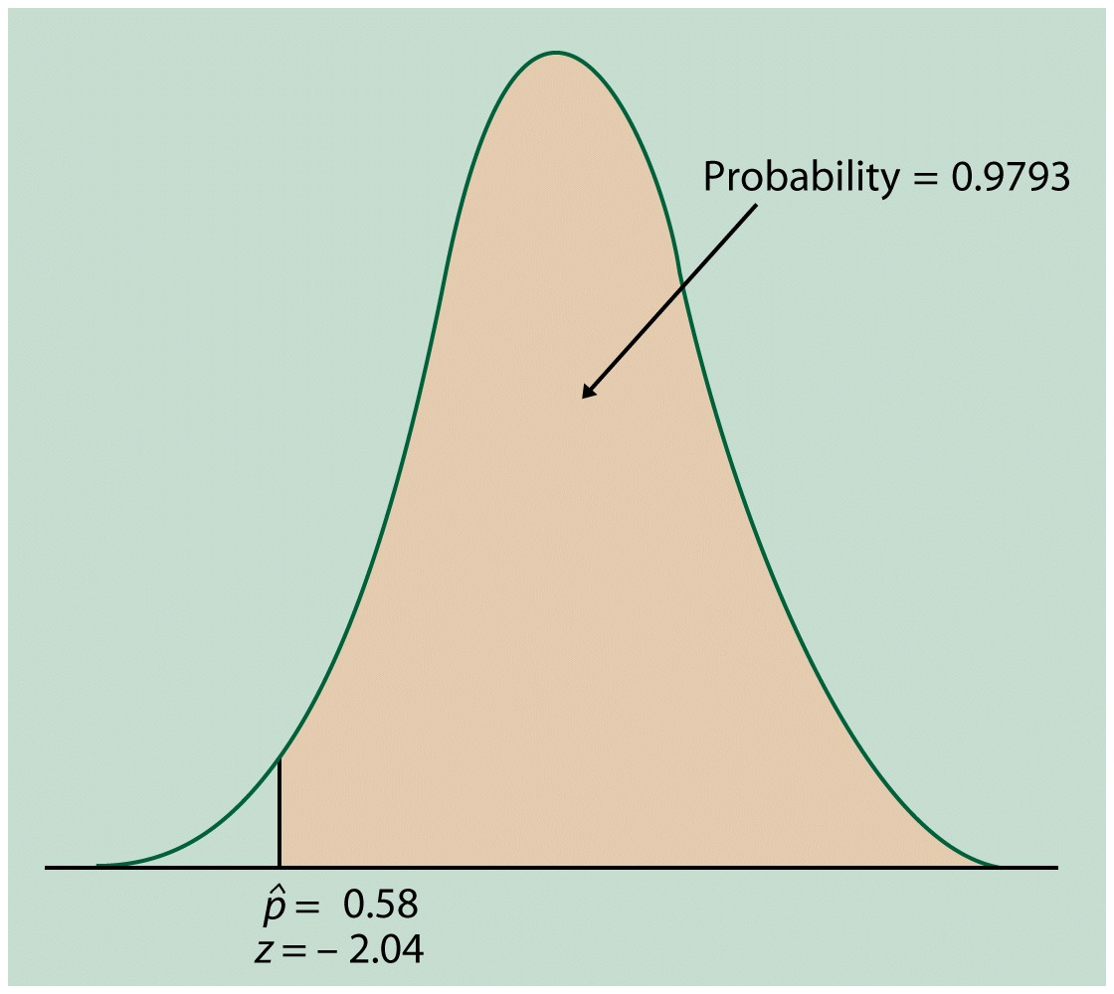
Figure 5.5 The normal probability calculation for Example 5.10

Let’s look at Example 5.11 (page # 345).

Binomial formulas

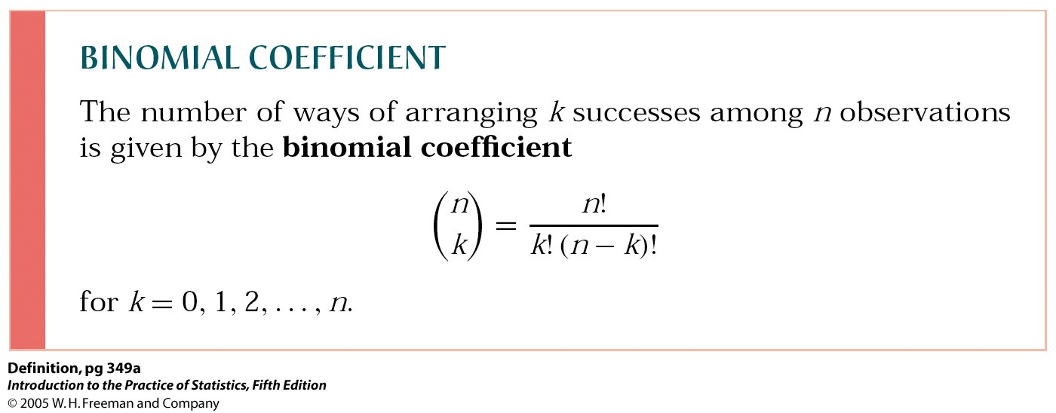

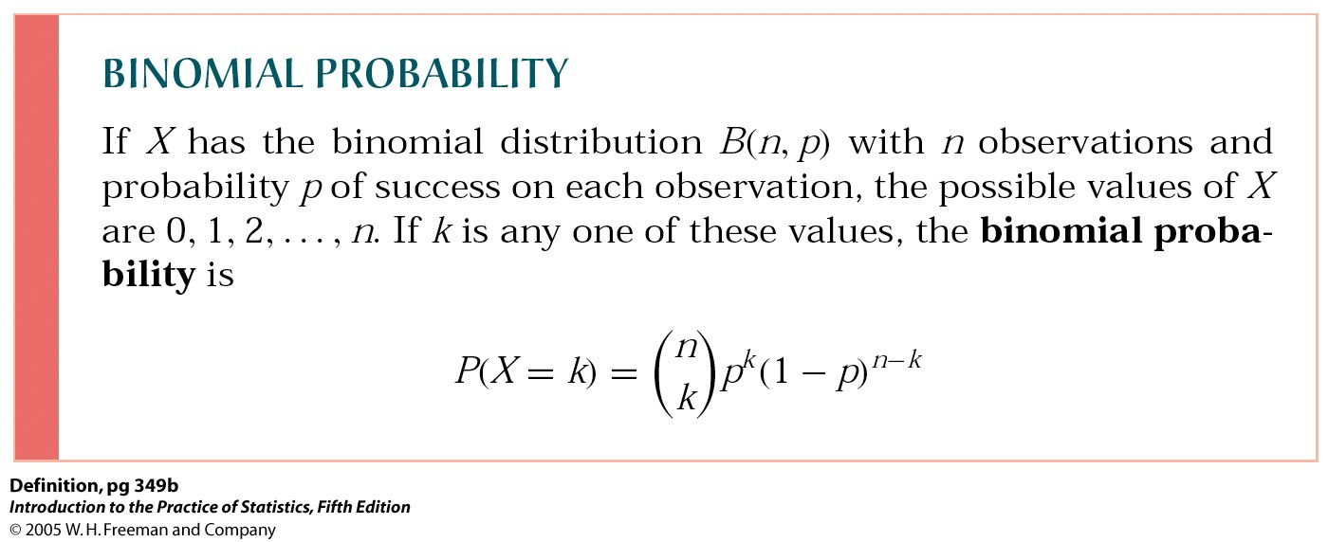

Let’s look at Example 5.13 (page # 350).

