Chapter 9: Inference for Two-Way Tables

Overview

In chapter 2 we studied relationships in which at least the response variable was quantitative. In this chpater we have a similar goal; but here both of the variables are categorical. Some variables-such as gender, race, and occupation-are inherently categorical.

This chapter discusses techniques for describing the relationship between two or more categorical variables. To analyze categorical variables, we use counts (frequencies) or percents (relative frequencies) of individuals that fall into various categories. A two-way table of such counts is used to organize data about two categorical variables. Values of the row variable label the rows that run across the table, and values of the column variable label the columns that run down the table. In each cell (intersection of a row and column) of the table, we enter the number of cases for which the row and column variables have the values (categories) corresponding to that cell.

The row totals and column totals in a two-way table give marginal distributions of the two variables separately.

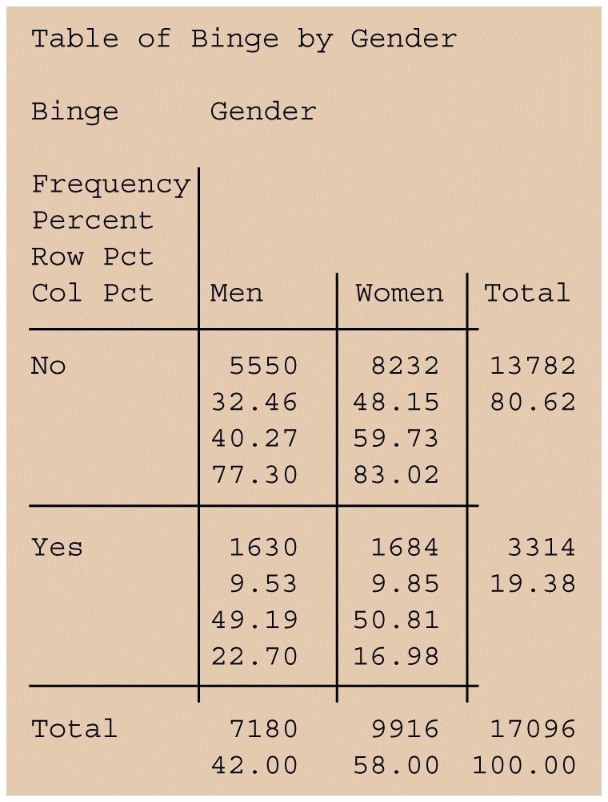

Figure. Computer output for the binge-drinking study

Computing expected cell counts

The null hypothesis is that there is no relationship between row variable and column variable in the population. The alternative hypothesis is that these two variables are related.

Here is the formula for the expected cell counts under the hypothesis of “no relationship”.
Expected Cell Counts

Expected count 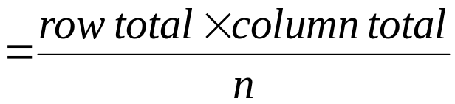

The null hypothesis is tested by the chi-square statistic, which compares the observed counts with the expected counts:

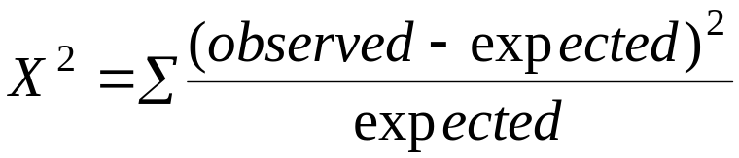

Under the null hypothesis, 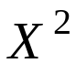 has approximately the 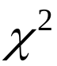 distribution with (r-1)(c-1) degrees of freedom. The P-value for the test is

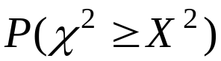

where is a random variable having the (df) distribution with df=(r-1)(c-1).

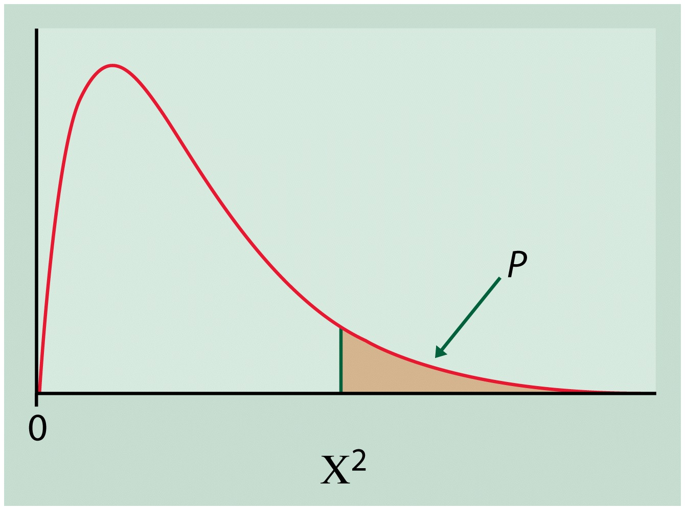

Figure. Chi-Square Test for Two-Way Tables

Example 1. In a study of heart disease in male federal employees, researchers classified 356 volunteer subjects according to their socioeconomic status (SES) and their smoking habits. There were three categories of SES: high, middle, and low. Individuals were asked whether they were current smokers, former smokers, or had never smoked, producing three categories for smoking habits as well. Here is the two-way table that summarizes the data:
observed counts for smoking and SES
 | SES
Smoking | High | Middle | Low | Total
Current | 51 | 22 | 43 | 116
Former | 92 | 21 | 28 | 141
Never | 68 | 9 | 22 | 99
Total | 211 | 52 | 93 | 356

This is a 33 table, to which we have added the marginal totals obtained by summing across rows and columns. For example, the first-row total is 51+22+43=116. The grand total, the number of subjects in the study, can be computed by summing the row totals, 116+141+99=356, or the column totals, 211+52+93=356.

Example 2. We must calculate the column percents. For the high-SES group, there are 51 current smokers out of total of 211 people. The column proportion for this cell is

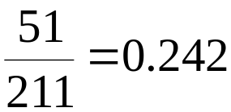

That is, 24.2% of the high-SES group are current smokers. Similarly, 92 out of the 211 people in this group are former smokers. The column proportion is

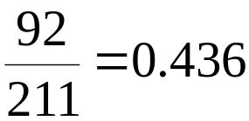

or 43.6%. In all, we must calculate nine percents. Here are the results:
Column percents for smoking and SES
 | SES
Smoking | High | Middle | Low | All
Current | 24.2 | 42.3 | 46.2 | 32.6
Former | 43.6 | 40.4 | 30.1 | 39.6
Never | 32.2 | 17.3 | 23.7 | 27.8
Total | 100.0 | 100.0 | 100.0 | 100.0

Example 3. What is the expected count in the upper-left cell in the table of Example 1, corresponding to high-SES current smokers, under the null hypothesis that smoking and SES are independent?

The row total, the count of current smokers, is 116. The column total, the count of high-SES subjects, is 211. The total sample size is n=356. The expected number of high-SES current smokers is therefore

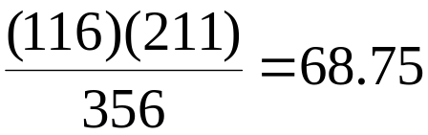

We summarize these calculations in a table of expected counts:

Expected counts for smoking and SES
 | SES
Smoking | High | Middle | Low | All
Current | 68.75 | 16.94 | 30.30 | 115.99
Former | 83.57 | 20.60 | 36.83 | 141.00
Never | 58.68 | 14.46 | 25.86 | 99.00
Total | 211.0 | 52.0 | 92.99 | 355.99

Computing the chi-square statistic

The expected counts are all large, so we preceed with the chi-square test. We compare the table of observed counts with the table of expected counts using the statistic. We must calculate the term for each, then sum over all nine cells. For the high-SES current smokers, the observed count is 51 and the expected count is 68.75. The contribution to the statistic for this cell is

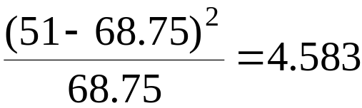

Similarly, the calculation for the middle-SES current smokers is

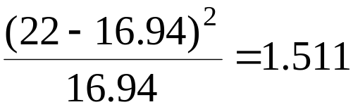

The statistic is the sum of nine such terms:

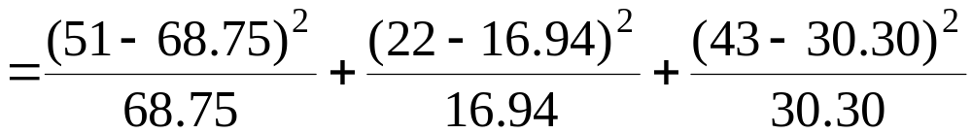

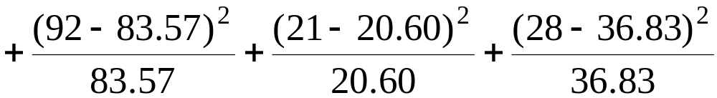

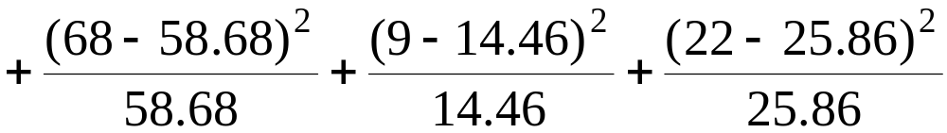

Because there are r=3 smoking categories and c=3 SES groups, the degrees of freedom for this statistic are

(r-1)(c-1)=(3-1)(3-1)=4

Under the null hypothesis that smoking and SES are independent, the test statistic has 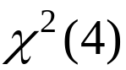 distribution. To obtain the P-value, refer to the row in Table F corresponding to 4 df.

The calculated value =18.51 lies between upper critical points corresponding to probabilities 0.001 and 0.0005. The P-value is therefore between 0.001 and 0.0005. Because the expected cell counts are all large, the P-value from Table F will be quite accurate. There is strong evidence (=18.51, df=4, P<0.001) of an association between smoking and SES in the population of federal employees.

χ2 Test of Independence Example
You’re a marketing research analyst. You ask a random sample of 286 consumers if they purchase Diet Pepsi or Diet Coke. At the .05 level, is there evidence of a relationship?

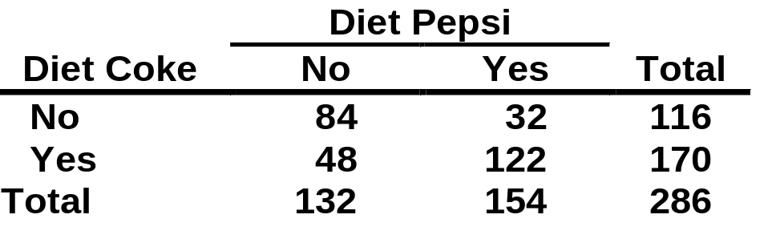

χ2 Test of Independence Solution
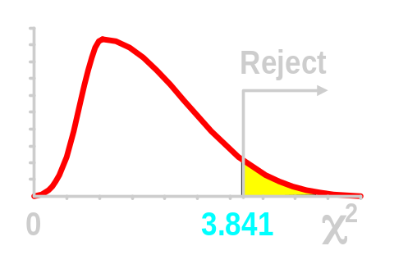
H0: No Relationship
Ha: Relationship
α = .05
df = (2 - 1)(2 - 1) = 1
Critical Value(s):
Test Statistic:

Decision:

Conclusion:

Reject at α = .05
There is evidence of a relationship
α = .05
χ² = 54.29

χ2 Test of Independence Thinking Challenge
OK. There is a statistically significant relationship between purchasing Diet Coke & Diet Pepsi. So what do you think the relationship is? Aren’t they competitors?
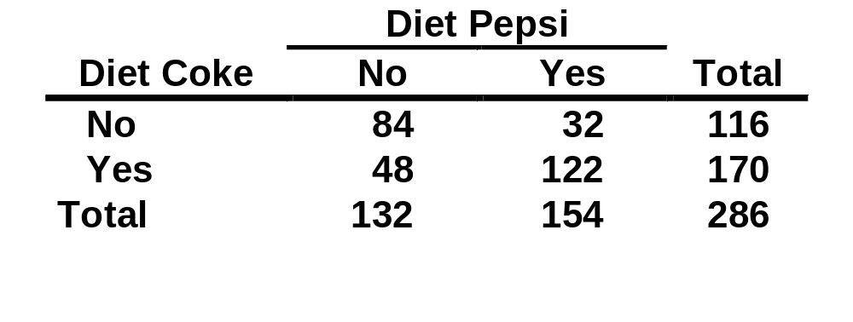

You Re-Analyze the Data
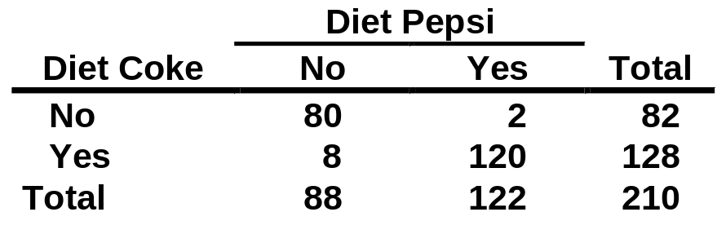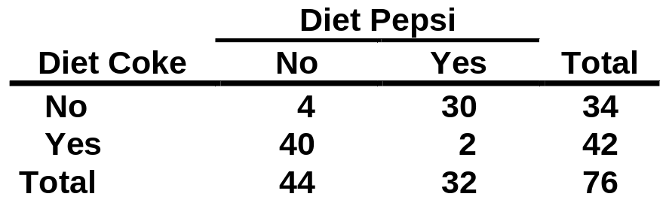
Low Income
High Income

True Relationships*


Apparent relation
Underlying causal relation
Control or intervening variable (true cause)
Diet Coke
Diet Pepsi

Conclusion

1. Explained χ2 Test for Proportions
2. Explained χ2 Test of Independence
3. Solved Hypothesis Testing Problems
  - Two or More Population Proportions
  - Independence

Using R-Web Software
Consider University of Illinois business school data:
Major | Female | Male
Accounting | 68 | 56
Administration | 91 | 40
Economics | 5 | 6
Finance | 61 | 59

- We wish to determine if the proportion female differs between the four majors.
- This is a test of the null hypothesis Ho: p_ac=p_ad=p_e=p_f
- We use the Pearson χ2 statistic, as in previous problems.
- If the test gives a small p-value, how do we determine if the groups differ?

χ2 Contributions

- Answer: We look at a table of contributions to the χ2 statistic.
- Cells with large values are contributing greatly to the overall discrepancy between the observed and expected counts.
- Large values tell us which cells to examine more closely.

Residuals
- As we have seen previously in regression problems, we can measure the deviation from what was observed from what is expected under the Ho by using a residual.



Residual Usage

- Think of these residuals as being on a standard normal scale.
- This means a residual of -3.26 means the observed count was far less (neg) than what would be expected under the Ho.
- A residual of 2.58 means the cell’s observed value was far above what would be expected under Ho.
- A residual like .24 or -.39 means the cell is not far from what would be expected under Ho.
- The sign + or – of the residual tells if the observed cell count was above or below what is expected under Ho.
- Abnormally large (in absolute value) residuals will also have large contributions to χ2.

Input the Table
- The R-Web command for inputting the Illinois student table data is:
- x <- matrix(c(68, 56, 91, 40, 5 , 6, 61, 59), nc = 2, byrow=T)
- This means input the cell counts by rows, where the table has 2 columns, (nc=2).
Obtaining Test Statistic & P-Val
- chisq.test(x)
- This command produces the Pearson χ2 test statistic, p-value, and degrees of freedom.

Contributions to χ2
- To find the cells that contribute most to the rejection of the Ho, type :
- chisq.test(x)$residuals^2

Residuals
- Type:
- chisq.test(x)$residuals

Observed & Expected Tables

- Type:
- chisq.test(x)$observed
chisq.test(x)$expected
- These will help you understand the table behavior.
Example
- Submit these commands:
x <- matrix(c(68, 56, 91, 40, 5 , 6, 61, 59), nc = 2, byrow=T)
chisq.test(x)
chisq.test(x)$residuals^2
chisq.test(x)$residuals
chisq.test(x)$observed
chisq.test(x)$expected
Pearson's Chi-squared test

data: x
X-squared = 10.8267, df = 3, p-value = 0.0127

Rweb:> chisq.test(x)$residuals^2
[,1] [,2]
[1,] 0.2534128 0.3541483
[2,] 2.8067873 3.9225288
[3,] 0.3109070 0.4344974
[4,] 1.1447050 1.5997431
Rweb:> chisq.test(x)$residuals
[,1] [,2]
[1,] -0.5034012 0.5951036
[2,] 1.6753469 -1.9805375
[3,] -0.5575903 0.6591641
[4,] -1.0699089 1.2648095
Rweb:> chisq.test(x)$observed
[,1] [,2]
[1,] 68 56
[2,] 91 40
[3,] 5 6
[4,] 61 59
Rweb:> chisq.test(x)$expected
[,1] [,2]
[1,] 72.279793 51.720207
[2,] 76.360104 54.639896
[3,] 6.411917 4.588083
[4,] 69.948187 50.051813
Example Conclusion

- First, note the p-value for the test is small and this means evidence the proportions female differ between the four majors.
- How do they differ?
- From the contributions to χ2 and the residuals we see the second row (Administration) has the biggest discrepancy between observed and expected counts.
- From either the residuals or the observed vs expected tables we see that females are much more likely to major in administration than would be expected and males less likely than expected under the Ho.
- The administration proportion is much higher than the others for females, and this is the primary major that produces the evidence that the majors differ.

