Cautions about Regression and Correlation

Key Words in Section 2.4

- Residuals
- Lurking variables and influential observation
Plots of the residuals, which are the differences between the observed and predicted values of the response variable, are very useful for examing the fit of a regression line. Features to look out for in a residual plot are unusually large values of the residuals (outliers), nonlinear patterns, and uneven variation about the horizontal line through zero (corresponding to uneven variation about the regression line).
Residuals

A residual is the difference between an observed value of the response variable and the value predicted by the regression line. That is,
Residual = observed y – predicted y

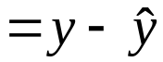

Example
When x= 24 months in Table 2.7, the observed mean height of Kalama children was 79.9 cm.
The least regression line is
cm
Residual = observed y – predicted y
cm

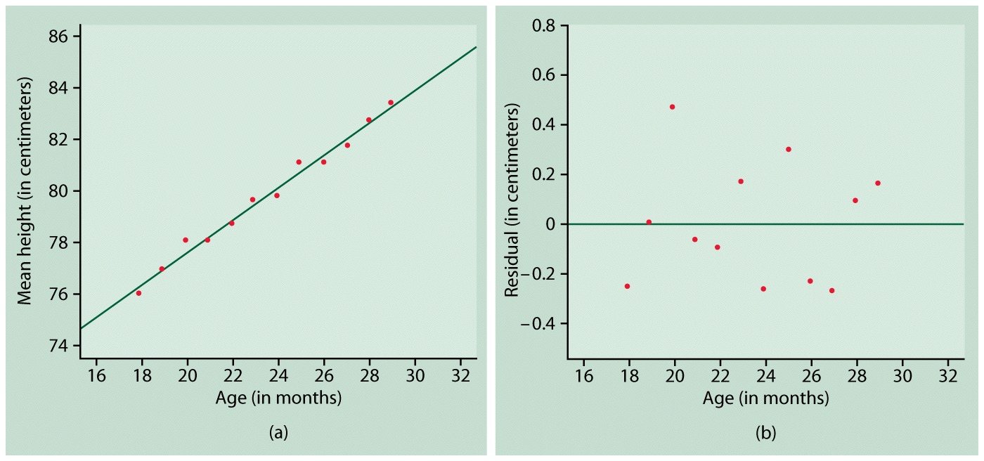

Figure (a) The Kalama growth data with the least-squares line. (b) Plot of the residuals from the regression in (a) against the explanatory variable.

Residual Plots

A residual plot is a scatterplot of the regression residuals against the explanatory variable. Residual plots help us assess the fit of a regression line.

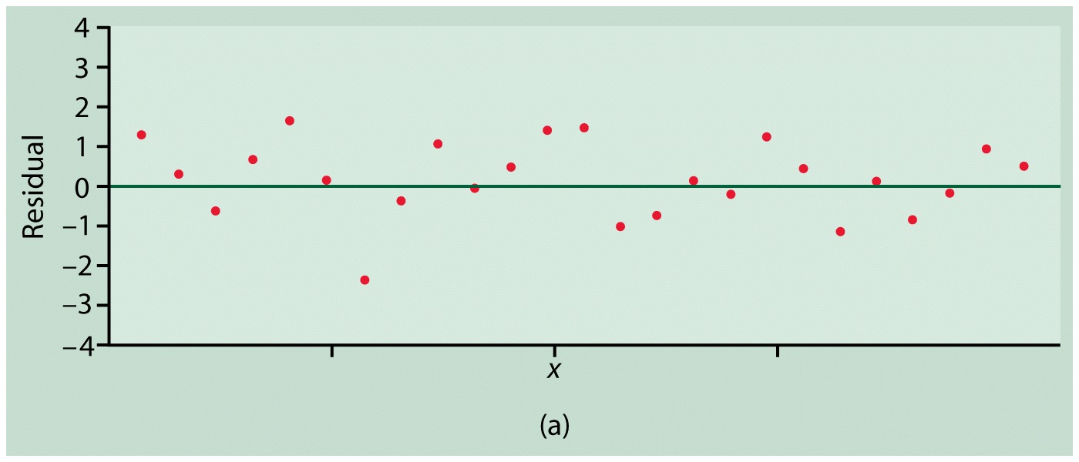

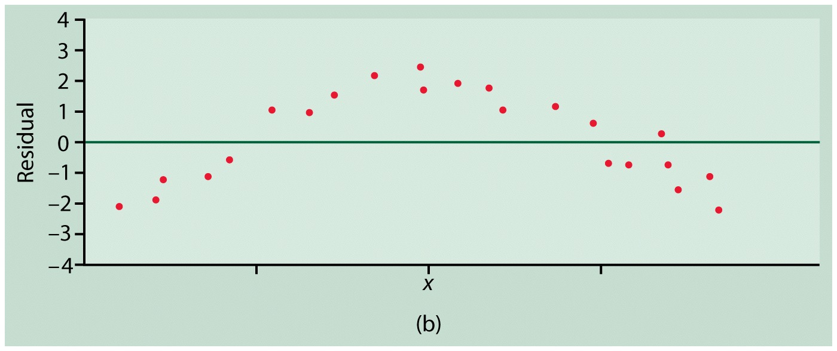

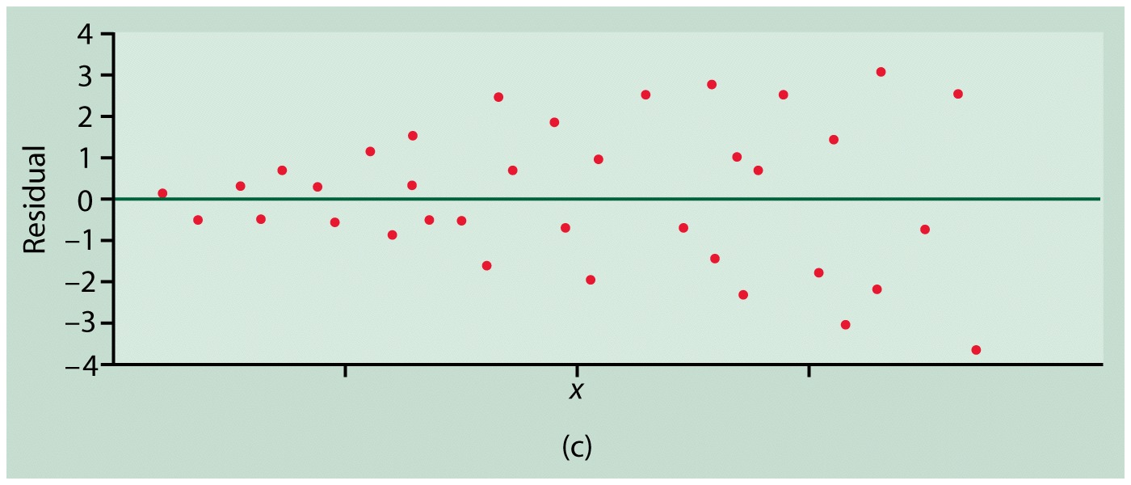

Figure Simplified patterns in plots of least-squares residuals.

Lurking Variable

A lurking variable is a variable that is not among the explanatory or response variables in a study and yet may influence the interpretation of relationships among those variables.

The effects of lurking variables, variables other than the explanatory variable which may also affect the response, can often be seen by plotting the residuals versus such variables. Linear or nonlinear trends in such a plot are evidence of a lurking variable. If the time order of the observations is known, it is good practice to plot the residuals versus time order to see if time can be considered a lurking variable.

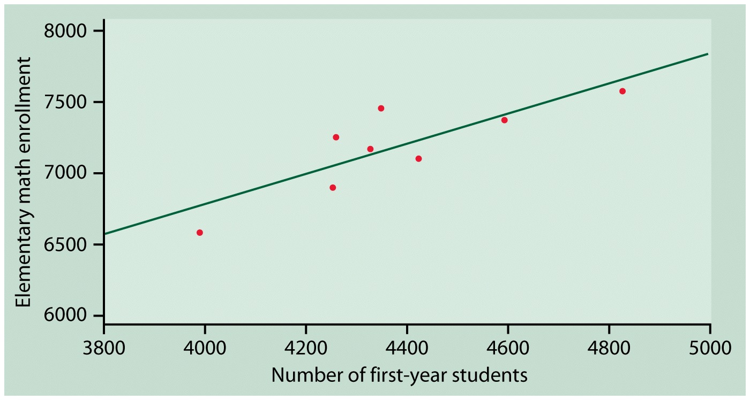

Figure The regression of elementary mathematics enrollment on number of first-year students at a large University.

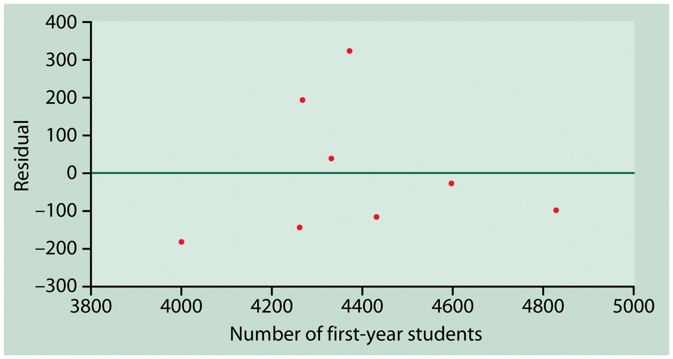Figure Residual plot for mathematics enrollment on number of first-year students.

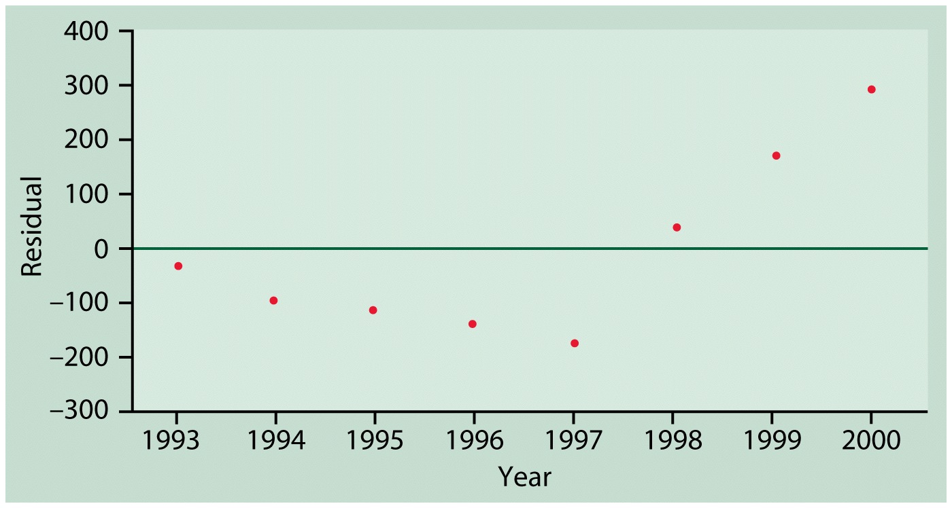
Figure Plot of the residuals against year for the regression of mathematics enrollment on number of first-year students.

Example 2.20. Please look at the page number 159.
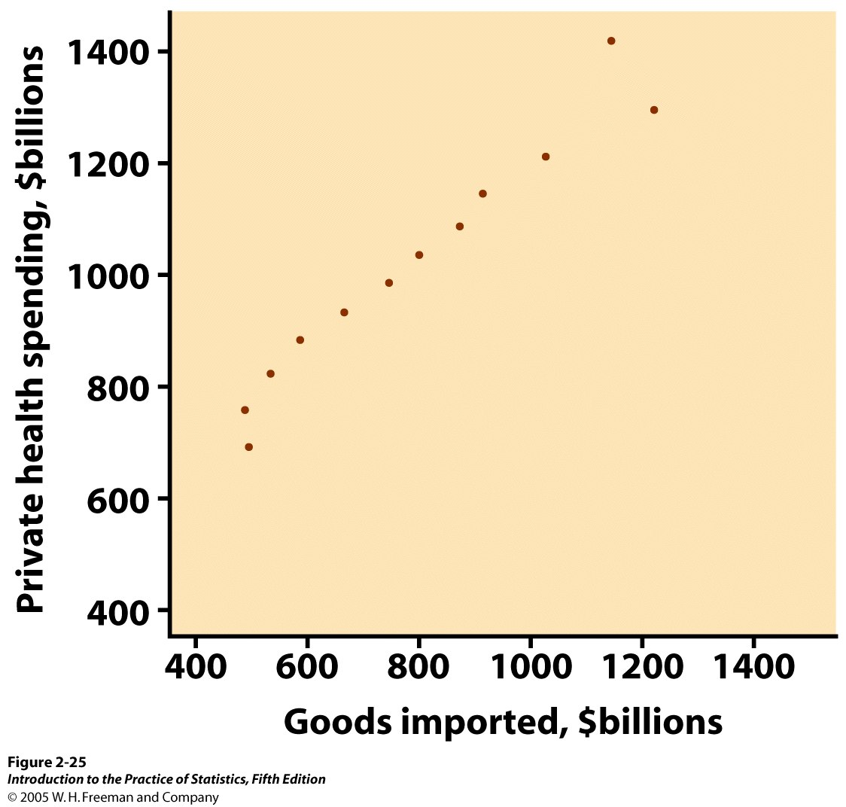

Outliers and Influential Observations
Outliers are points that do not follow the pattern of the other points in the dataset. These points typically have y-values that are either much above or below the least squares line. That is, they have large residuals in absolute value.
Influential observations are individual points whose removal would cause a substantial change in the regression line. Influential observations are often outliers in the horizontal direction but they need not have large residuals.

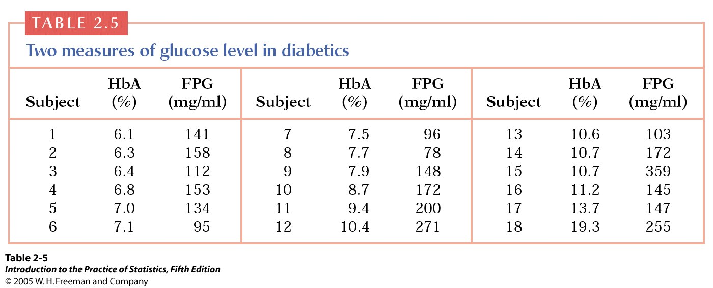

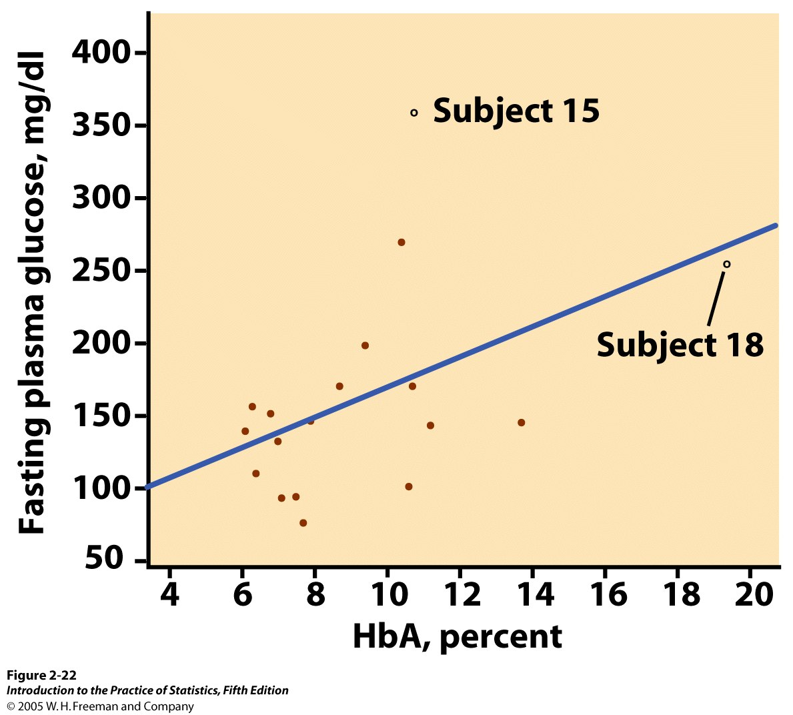

Figure 2.22 Scatterplot of fasting plasma glucose against HbA (which measures long-term blood glucose), with the least-squares line, for Example 2.17

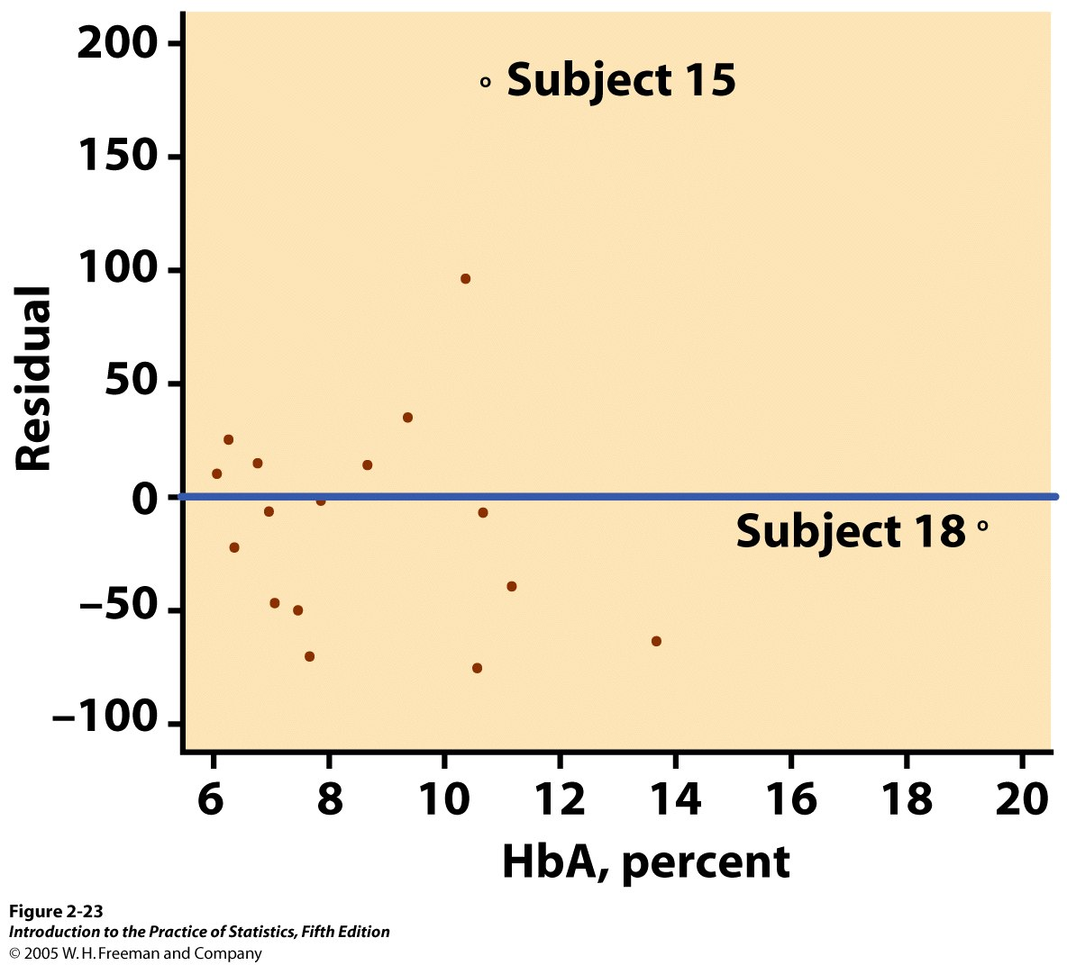

Figure 2.23 Residual plot for the regression of FPG on HbA. Subject 15 is an outlier in y. Subject 18 is an outlier in x that may be influential but does not have a large residual.

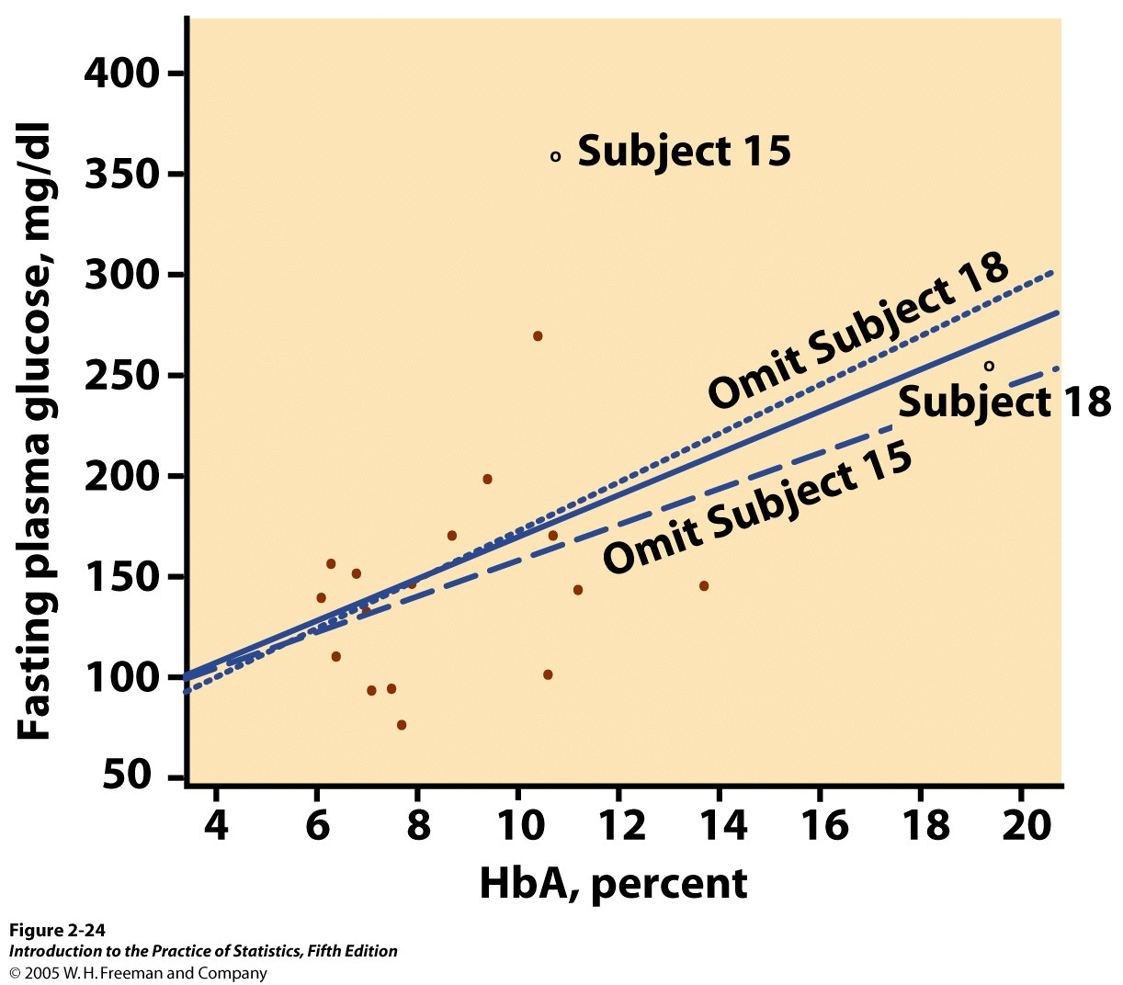

Figure 2.24 Three regression lines for predicting FPG from HbA, for Example 2.18. The solid line uses all 18 subjects. The dotted line leaves out Subject 18. The dashed line leaves out Subject 15. “Leaving one out” calculations are the surest way to assess influence.

Remark
Correlation and regression must be interpreted with caution. Plots of the data, including residual plots, help make sure the relationship is roughly linear and help to detect outliers and influential observations. The presence of lurking variables can make a correlation or regression misleading. Always remember that association, even strong association, does not imply a cause-and effect relationship between two variables.

The Question of Causation

Key Words in Section 2.5

- Common response
- Confounding
An observed association between two variables can be due to several things. It can be due to a cause-and-effect relationship between the variables. It can also be due to the effects of lurking variables, i.e., variables not directly studied that may effect the response and possibly the explanatory variable.

In this section, we need think about the following questions:
- What ties between two variables (and others luking in the background) can explain an observed association?
- What constitutes good evidence for causation?

Example 2.23
Here are some examples of observed association between x and y:
1. x = mother’s body mass index
y = daughter’s body mass index
2. x = amount of the artificial sweetener
saccharin in a rat’s diet
y = count of tumors in the rat’s bladder
3. x = a student’s SAT score as a high school senior
y = the student’s first-year college GPA
4. x = monthly flow of money into stock mutual funds
y = monthly rate of return for the stock market
5. x = whether a person regularly attends
religious services
y = how long the person lives
6. x = the number of years of education a worker has
y = the worker’s income

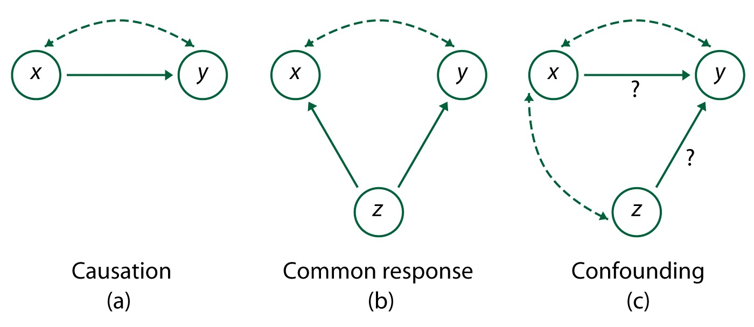
Figure 2.29 Some explanations for an observed association. The dashed-arrow lines show an association. The solid arrows show a cause-and-effect link. The variable x is expanatory, y is a response vairiable, and z is a lurking variable.

Common response

The second diagram in Figure 2.29 illustrats common response. The observed association between the variables x and y is explained by a lurking variable z.

Confounding

Two variables are confounded when their effects on a response variable cannot be distinguished from each other. The confounded variables may be either explanatory variables or lurking variables.
Example 2.24
Items 1 and 2 in Example 2.23 are examples of direct causations. For the reasons, please look at the page 180 in our textbook.

Example 2.25
Items 3 and 4 in Example 2.23 illustrate how common response can create an association. For the reasons, please look at the page 181 in our textbook.

Example 2.26
Items 5 and 6 in Example 2.23 are explained in part by confounding. For the reasons, please look at the page 182 in our textbook.
Lurking variables may operate through common response, in which case changes in the lurking variable. Lurking variables may also cause confounding, in which case both the explanatory variable and the lurking variables cause changes in the response, but we cannot distinguish their individual effects.

Note
The best way to determine if an association is due to a cause-and-effect relationship between the explanatory variable and the response is through an experiment in which we control the influences of other variables. In the absence of good experimental evidence, be cautious in accepting claims of many studies, a clear explanation for the alleged cause-and-effect relationship, and careful examination of possible lurking variables.

