Chapter 7: Inference for Means

7.1 Inference for the Mean of a Populaton

Overview

Confidence intervals and significance tests for the mean 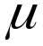 of a normal population are based on the sample mean 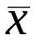 of an SRS. When the sample size n is large, the central limit theorem suggests that these procedures are approximately correct for other population distributions. In Chapter 6, we considered the (unrealistic) situation in which we knew the population standard deviation 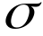. In this section, we consider the more realistic case where is not known and we must estimate from our SRS by the sample standard deviation 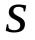. In Chapter 6 we used the one-sample z statistic

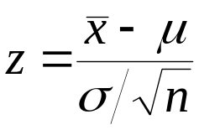

which has the N(0,1) distribution.

Replacing by , we now use the one sample t statistic

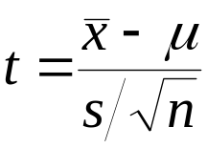

which has the t distribution with n-1 degrees of freedom.

When is not known, we estimate it with the sample standard deviation , and then we estimate the standard deviation of by 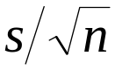.

Standard Error
When the standard deviation of a statistic is estimated from the data, the result is called the standard error of the statistic. The standard error of the sample mean is
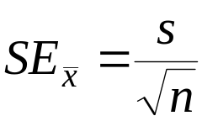

The t Distributions
Suppose that an SRS of size n is drawn from an N(,) population. Then the one-sample t statistic
has the t distribution with n-1 degrees of freedom.

Degrees of freedom

There is a different t distribution for each sample size. A particular t distribution is specified by giving the degrees of freedom. The degrees of freedom for this t statistic come from the sample standard deviation in the denominator of t.

History of Statistics

The t distribution were discovered in 1908 by William S. Gosset. Gosset was a statistician employed by the Guinness brewing company, which required that he not publish his discoveries under his own name. He therefore wrote under the pen name “Student.” The t distribution is called “Student’s t” in his honor.

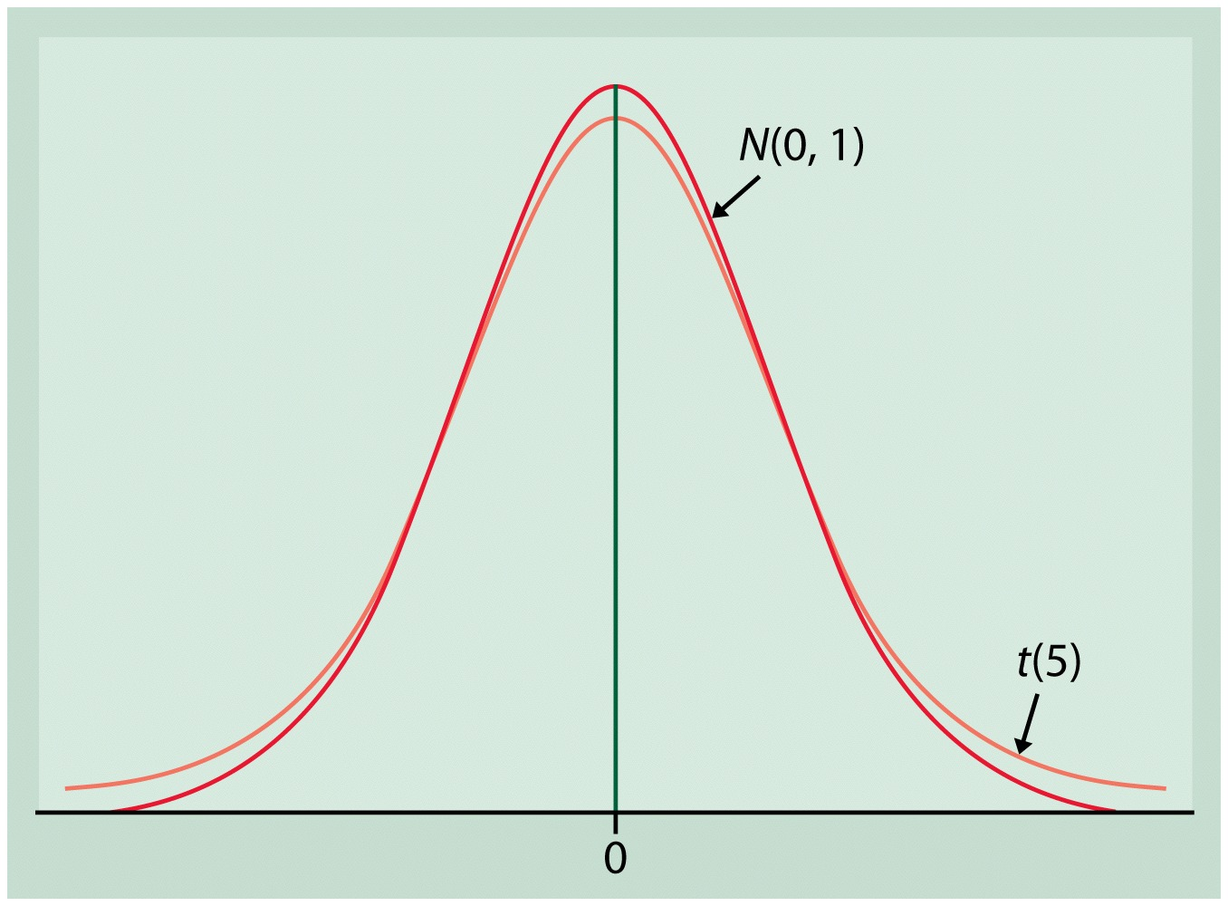

Figure 1. Density Curve for the standard normal and t(5) distributions. Both are symmetric with center 0. The t distributions have more probability in the tails than does the standard normal distribution due to the extra variability caused by substituting the random variable for the fixed parameter .

We use t(k) to stand for the t distribution with k degrees of freedom.

The One-Sample t Confidence Interval
Suppose that an SRS of size n is drawn from a population having unknown mean . A level C confidence interval for is
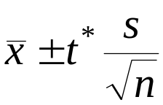
where t* is the value for the t(n-1) density curve with area C between –t* and t*. This interval is exact when the population distribution is normal and is approximately correct for large n in other cases.

So the Margin of error for the population mean when we use the data to estimate is

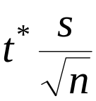

Example 1 In fiscal year 1996, the U.S. Agency for international Development provided 238,300 metric tons of corn soy blend (CSB) for development programs and emergency relief in countries throughout the world. CSB is a high nutritious, low-cost fortified food that is partially precooked and can be incorporated into different food preparations by the recipients. As part of a study to evaluate appropriate vitamin C levels in this commodity, measurements were taken on samples of CSB produced in a factory.

The following data are the amounts of vitamin C, measured in miligrams per 100 grams of blend (dry basis), for a random sample of size 8 from a production run:

26, 31, 23, 22, 11, 22, 14, 31

We want to find 95% confidence interval for , the mean vitamin C content of the CSB produced during this run. This sample mean is 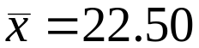 and the standard deviation is 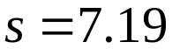 with degrees of freedom n-1=7. The standard error is

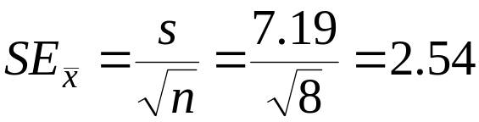

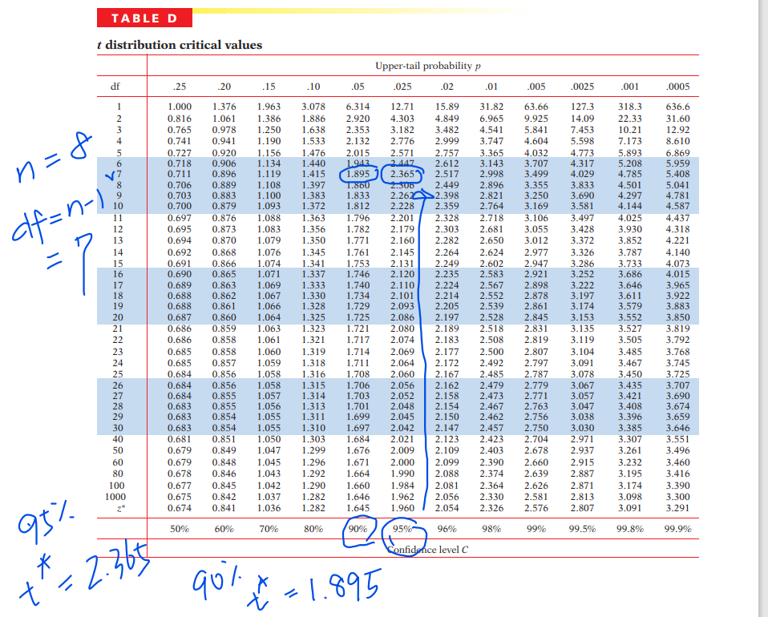

From Table D we find t*=2.365. The 95% confidence interval is

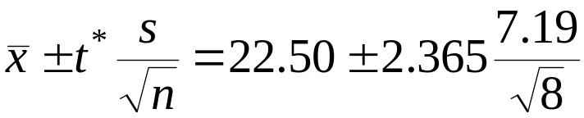

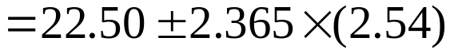

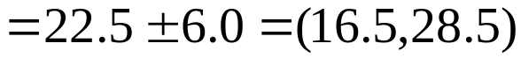.

We are 95% confident that the mean vitamin C content of the CSB for this run is between 16.5 and 28.5 mg/100 g.

The One-Sample t Test
Suppose that an SRS of size n is drawn from a population having unknown mean . To test the hypothesis 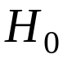: 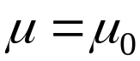 based on an SRS of size n, compute the one-sample t statistic
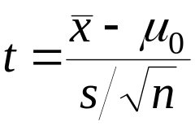
In terms of a random variable T having t(n-1) distribution, the P-value for a test of against
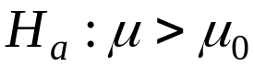 is P(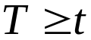)
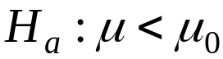 is P(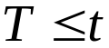)
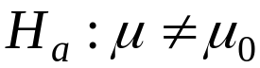 is 2P(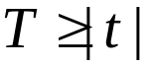)
These P-values are exact if the population distribution is normal and are approximately correct for large n in other cases.

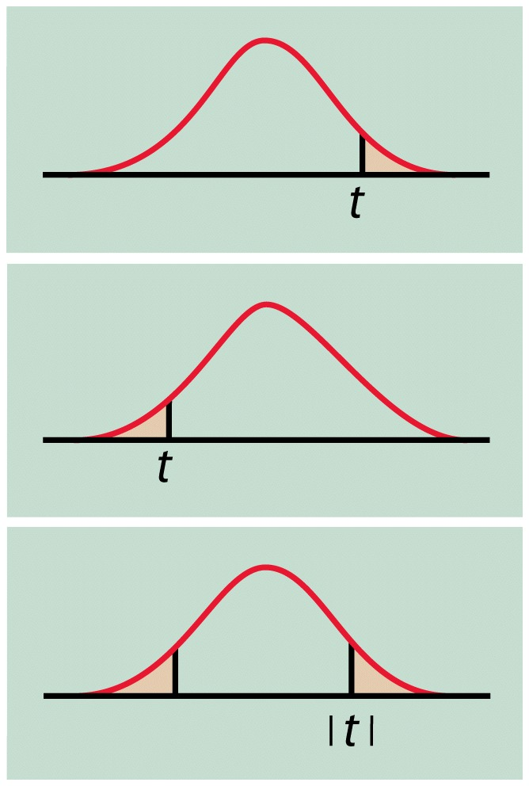

Example 2 The specifications for the CBS described in Example 1 state that the mixture should contain 2 pounds of vitamin permix for every 2000 pounds of product. These specifications are designed to produce a mean () vitamin C content in the final product of 40mg/100g. We can test a null hypothesis that the mean vitamin C content of the production run in Example 1 conforms to these specifications. Specifically, we test

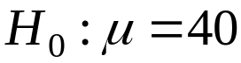

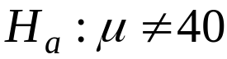

Recall that 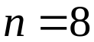, , and .

The t test statistics is

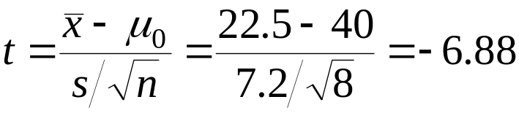

Because the degrees of freedom are n-1=7, this t statistic has the t(7) distribution.

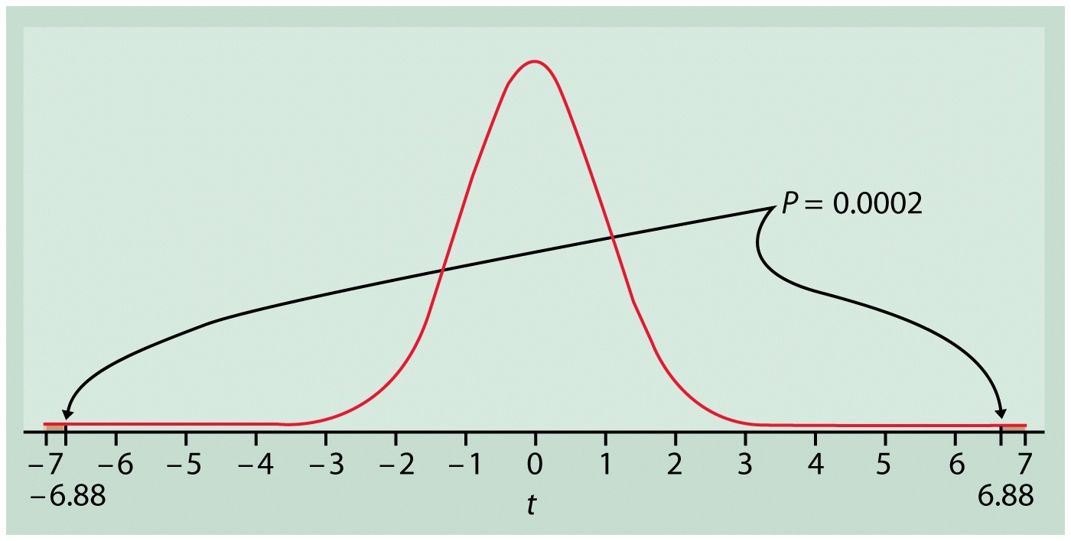

Figure 2 The P-value for Example 2.

Figure 2 shows that the P-value is 2P(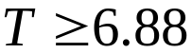), where T has the t(7) distribution. From Table D we see that P(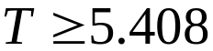)=0.0005. Therefore, we conclude that the P-value is less than 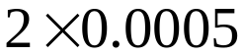. Since P-value is smaller than 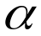=0.05, we can reject and conclude that the vitamin C content for this run is below the specifications.

Example 3 For the vitamin C problem described in the previous example, we want to test whether or not vitamin C is lost or destroyed by the production process. Here we test

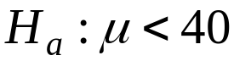

The t test statistic does not change: 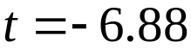. 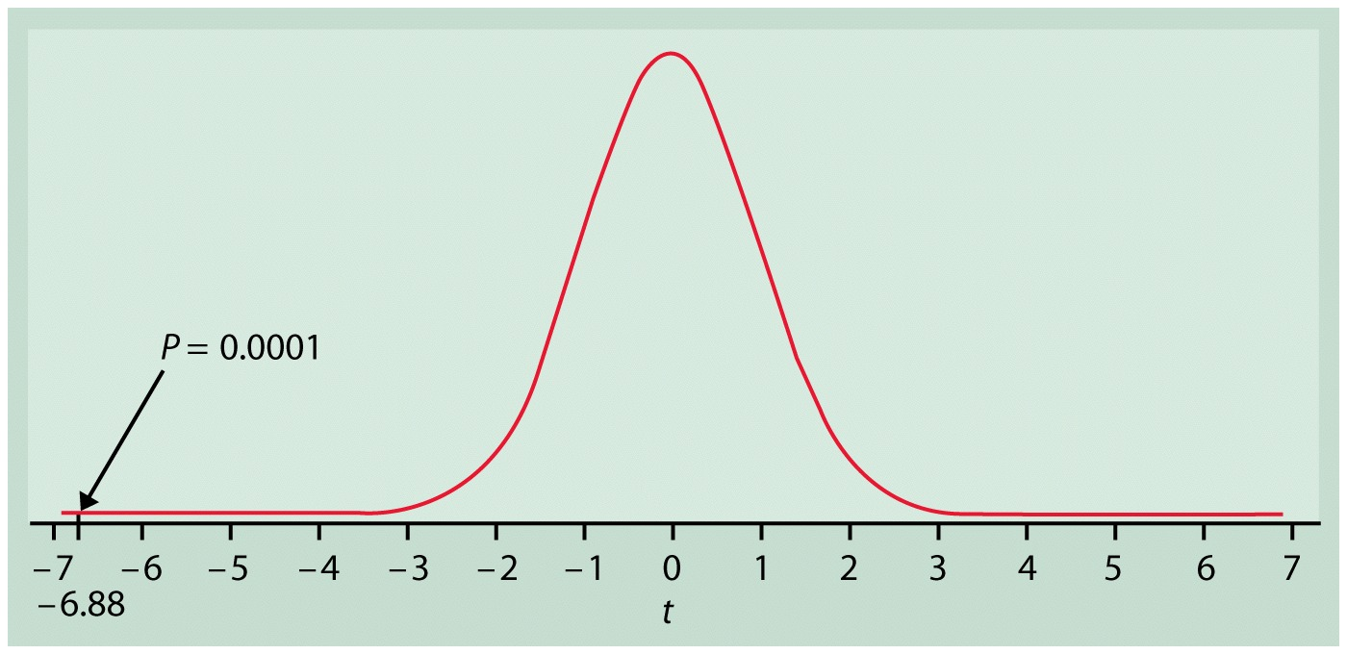

Figure 3 The P-value for Example 3.

As Figure 3 illustrates, however, the P-value is now P(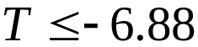). From Table D we can determine that 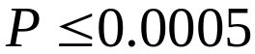. We conclude that the production process has lost or destroyed some of the vitamin C.

Matched Pairs t procedures

One application of these one-sample t procedures is to the analysis of data from matched pairs studies. We compute the differences between the two values of a matched pair (often before and after measurements on the same unit) to produce a single sample value. The sample mean and standard deviation of these differences are computed.

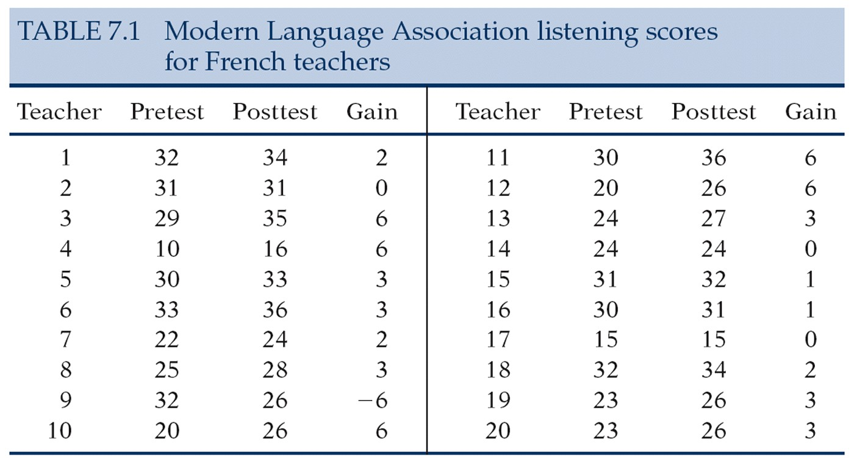

Example 4 To analyze these data, we first substract the pretest score from the posttest score to obtain the improvement for each student. These 20 differences form a single sample. They appear in the “Gain” columns in Table 7.1. The first teacher, for example, improved from 32 to 34, so the gain is 34-32=2.

To assess whether the institute significantly improved the teachers’ comprehension of spoken French, we test

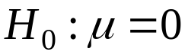

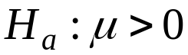

Here is the mean improvement that would be achieved if the entire population of French teachers attended a summer institute. The null hypothesis says that no improvement occurs, and 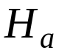 says that posttest scores are higher on the average. The 20 differences have

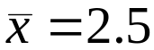 and 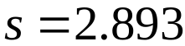

The one-sample t statistic is

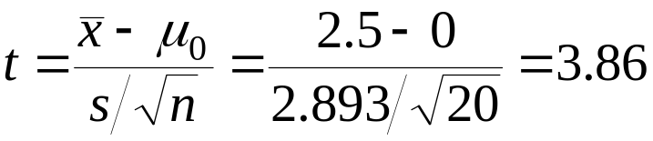

The P-value is found from the t(19) distribution (n-1=20-1=19). Table D shows that 3.86 lies between the upper 0.001 and 0.0005 critical values of the t(19) distribution. The P-value lies between 0.0005 and 0.001. Software gives the value P=0.0053. “The improvement in score was significant (t=3.86, df=19, p=0.00053).”

Example 5 A 90% confidence interval for the mean improvement in the entire population requires the critical value t*=1.729 from Table D. The confidence interval is

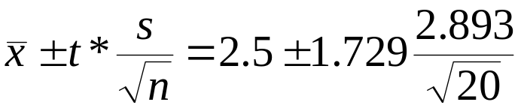

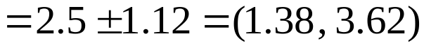

The estimated average improvement is 2.5 points, with margin of error 1.12 for 90% confidence. Though statistically significant, the effect of the institute was rather small.

