7.2 Comparing Two Means

Overview

One of the most commonly used significance tests is the comparison of two population means 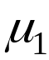 and 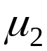.
Two-sample Problems
- The goal of inference is to compare the responses in two groups.
- Each group is considered to be a sample from a distinct population.
- The responses in each group are independent of those in the other group.

A two sample problem can arise from a randomized comparative experiment that randomly divides the subjects into two groups and exposes each group to a different treatment. Unlike the matched pairs designs studied earlier, there is no matching of the units in the two samples, and the two samples may be of different sizes. Inference procedures for two-sample data differ from those for matched pairs.

The two sample z statistic

Example 1 A fourth-grade class has 10 girls and 7 boys. The difference 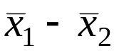 between the female and male mean heights varies in different random samples. The sampling distribution has mean 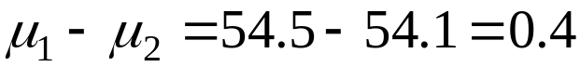 inch

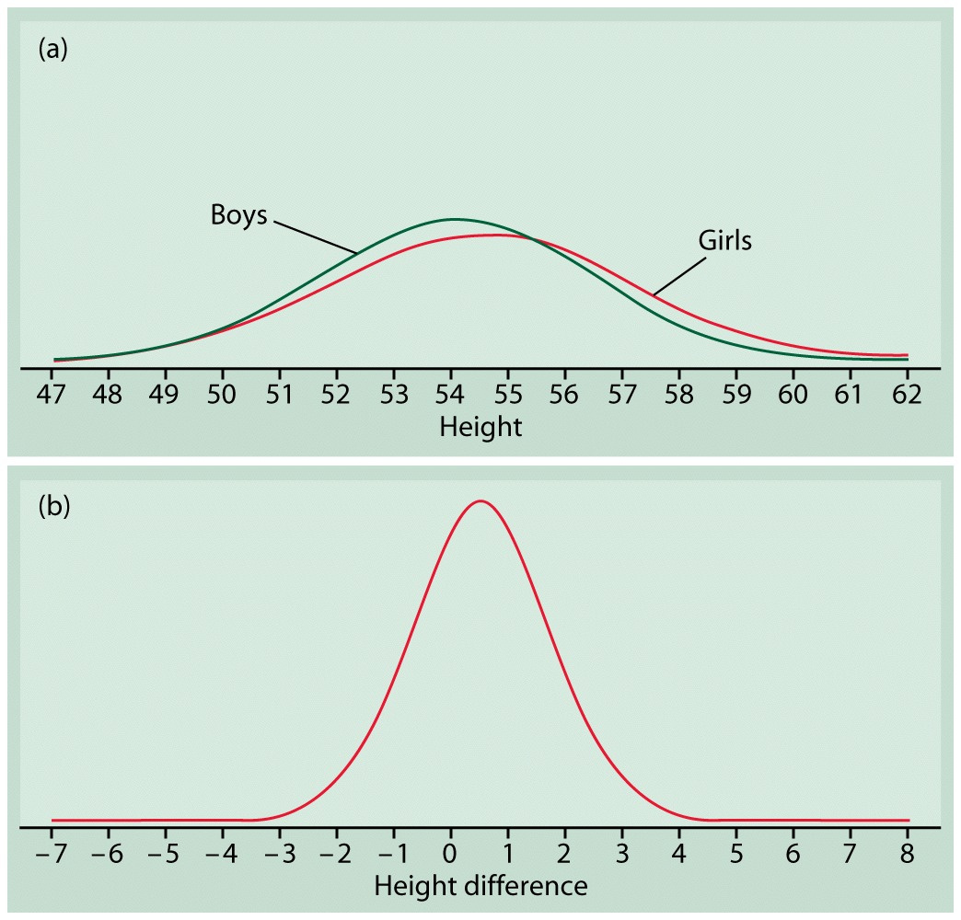

Figure Distributions for Example 7.13. (a) Distributions of heights of 10-year-old boys and girls. (b) Distribution of the difference between means of 10 girls and 7 boys.

Two-Sample z Statistic
Suppose that 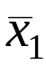 is the mean of an SRS of size 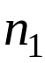 drawn from N( , 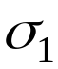 ) population and that 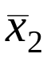 is the mean of an SRS of size 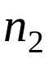 drawn from N( , 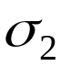 ) population. Then the two-sample z statistic
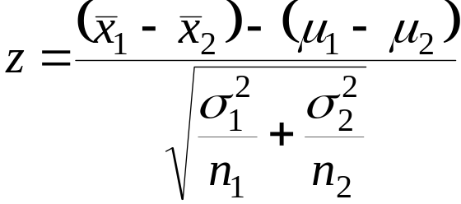
has the standard normal N(0,1) sampling distribution.

In the unlikely event that both population standard deviations are known, the two-sample z statistic is the basis for inference about 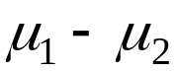. Exact z procedures are seldom used because and are rarely known.

The two-sample t procedures

Suppose that the population standard deviations and are not known. We estimate them by the sample standard deviations 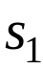 and 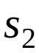 from our two samples.
The Two-Sample t Significance test
Suppose that an SRS of size is drawn from a normal population with unknown mean and that an independent SRS of size is drawn from another normal population with unknown mean . To test the hypothesis 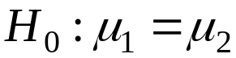, compute the two-sample t statistic
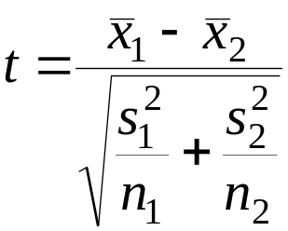
and use P-values or critical values for the t(k) distribution, where the degrees of freedom k are the smaller 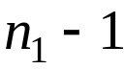 and 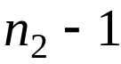.

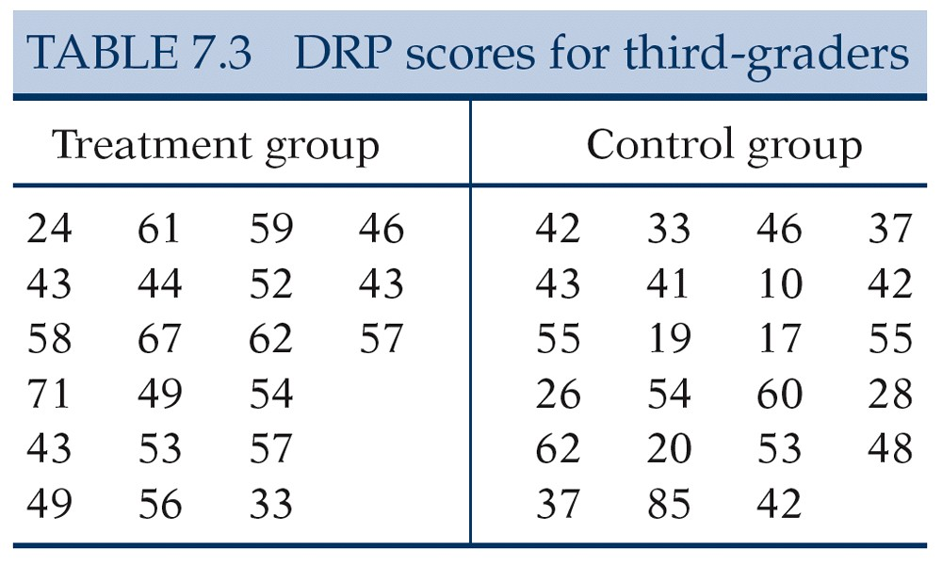

Example 2 An educator believes that new directed reading activities in the classroom will help elementary school pupils improve some aspects of their reading ability. She arranges for a third-grade class of 21 students to take part in these activities for an eight-week period. A control classroom of 23 third-graders follows the same curriculum without the activities. At the end of the eight weeks, all students are given a Degree of Reading Power (DRP) test, which measures the aspects of reading ability that the treatment is designed to improve. The summary statistics using Excel are

 | Treatment Group | Control Group
Mean | 51.47619048 | 41.52173913
Standard Error | 2.402002188 | 3.575758061
Median | 53 | 42
Mode | 43 | 42
Standard Deviation | 11.00735685 | 17.14873323
Sample Variance | 121.1619048 | 294.0790514
Kurtosis | 0.803583546 | 0.614269919
Skewness | -0.626692173 | 0.309280608
Range | 47 | 75
Minimum | 24 | 10
Maximum | 71 | 85
Sum | 1081 | 955
Count | 21 | 23

Because we hope to show that the treatment (Group 1) is better than the control (Group 2), the hypotheses are

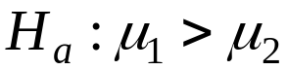
The two-sample t statistic is

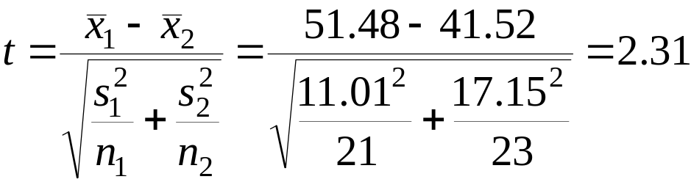

The P-value for the one-sided test is 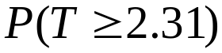. The degree of freedom k is equal to the smaller of 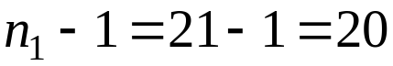 and 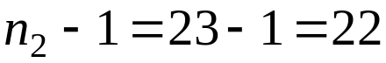. Comparing 2.31 with entries in Table D for 20 degrees of freedom, we see that P lies between 0.02 and 0.01. The data strongly suggest that directed reading activity improves the DRP score (t=2.31, df=20, 0.01<P<0.02).
The Two-Sample t Confidence Interval
Suppose that an SRS of size is drawn from a normal population with unknown mean and that an independent SRS of size is drawn from another normal population with unknown mean . The confidence interval for is given by
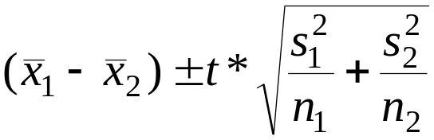
has confidence level at least C no matter what the population standard deviations may be. Here, t* is the value for the t(k) density curve with area C between –t* and t*. The value of the degrees of freedom k is the smaller of and .

Example 3. We will find a 95% confidence interval for the mean improvement in the entire population of third-graders. The interval is

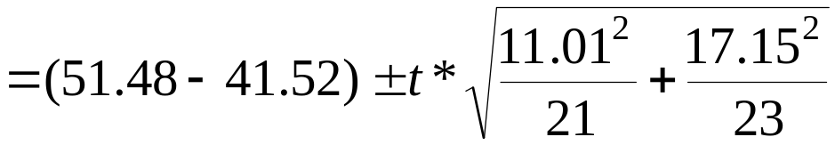

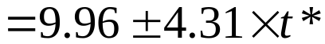

From Example 7.2, we have the t(20) distribution. Table D gives 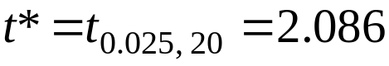. With this approximation we have

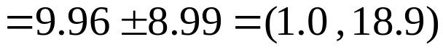

We can see that zero is outside of the interval (1.0, 18.9). We can say that “ is not equal to zero”.

Example 4. The Chapin Social Insight Test is a psychological test designed to measure how accurately the subject appraises other people. The possible scores on the test range from 0 to 41. During the development of the Chapin test, it was given to several different groups of people. Here are the results for male and female college students majoring in the liberal arts.
Group | Sex | 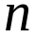 | 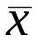 | 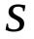
1 | Male | 133 | 25 | 5.1
2 | Female | 162 | 25 | 5.4

Do these data support the contention that female and male students differ in average social insight?

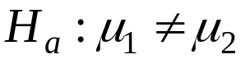

The two-sample t statistic is

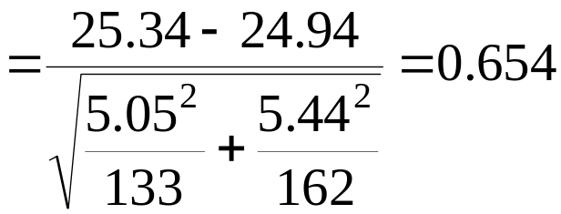

We find the P-value by comparing 0.654 to critical values for the t(132) distribution and then doubling p because the alternative is two-sided. Table D (for 100 degrees of freedom) shows that 0.654 does not reach the 0.25 critical value, which is the largest entry for p in this table. The P-value is therefore greater than 0.50. The data give no evidence of a gender difference in mean social insight score (t=0.654, df=132, P>0.50).

The Pooled two-sample t procedures

The pooled two-sample t procedures are used when we can safely assume that the two populations have equal variances. The modifications in the procedure are the use of the pooled estimator of the common unknown variance

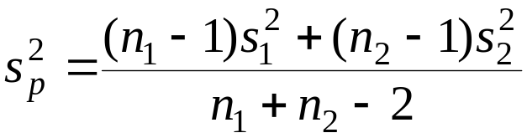.

This is called the pooled estimator of 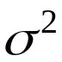.

When both populations have variance , the addition rule for variances says that has variance equal to the sum of the individual variances, which is

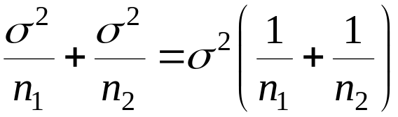

The standardized difference of means in this equal-variance case is

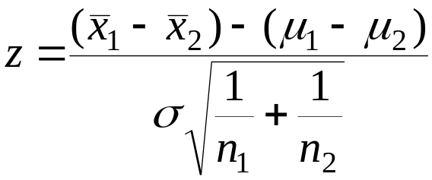

This is a special two-sample z statistic for the case in which the populations have the same 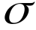. Replacing the unknown by the estimates 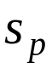 gives a t statistic. The degrees of freedom are 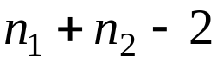.

The Polled Two-Sample t Procedures
Suppose that an SRS of size is drawn from a normal population with unknown mean and that an independent SRS of size is drawn from another normal population with unknown mean . Suppose also that the two populations have the same standard deviation. A level C confidence interval given by
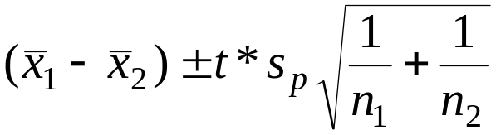
Here t* is the value for 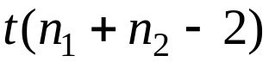 density curve with area C between –t* and t*.
To test the hypothesis ,compute the pooled two-sample t statistic
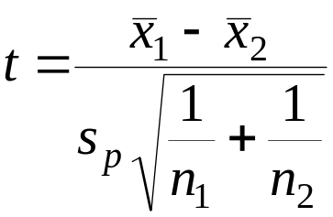
In terms of a random variable T having the t(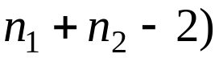 distribution, the P-value for a test of 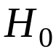 against
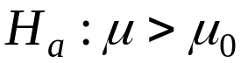 is P(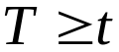)
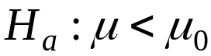 is P(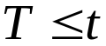)
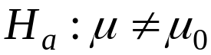 is 2P(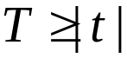)

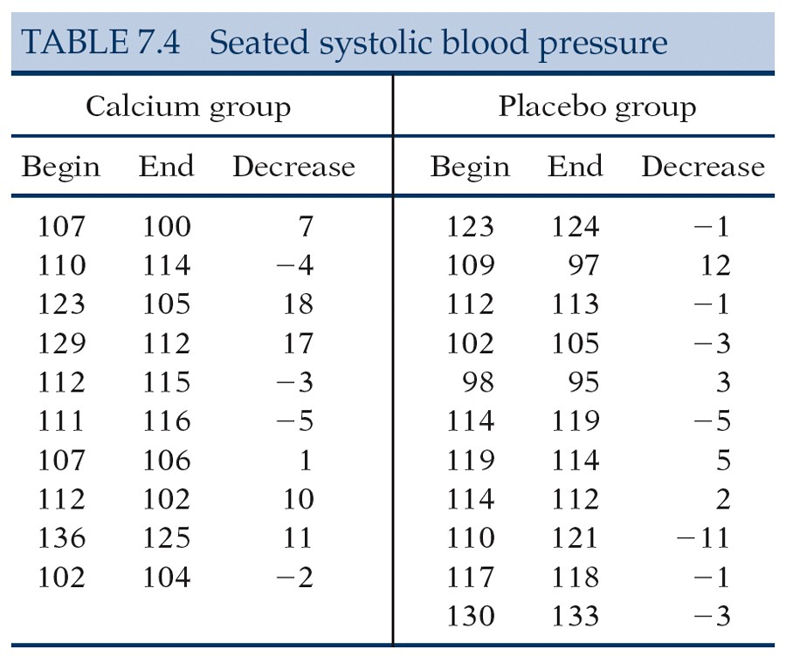

Example 5. Take Group 1 to be the calcium group and Group 2 to be the placebo group. The evidence that calcium lowers blood pressure more than a placebo is assessed by testing

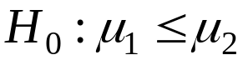

Here are the summary statistics for the decrease in blood pressure:
Group | Treatment
1 | Calcium | 10 | 5.000 | 8.743
2 | Placebo | 11 | -0.273 | 5.901

The calcium group shows a drop in blood pressure, and the placebo group has a small increase. The sample standard deviations do not rule out equal population standard deviations. A difference this large will often arise by chance in samples this small. We are willing to assume equal population standard deviations. The pooled sample variance is

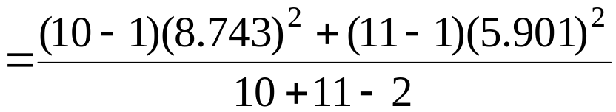

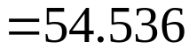.

So that 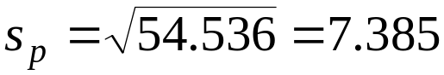

The pooled two-sample t statistic is
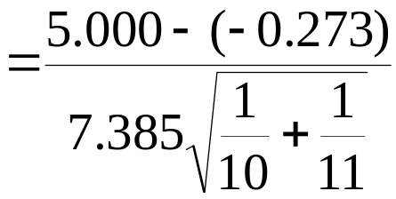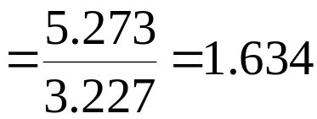

The P-value is 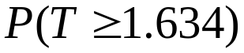, where T has t(19) distribution. From Table D, we can see that P lies between 0.05 and 0.10. The experiment found no evidence that calcium reduces blood pressure (t=1.634, df=19, 0.05<P<0.10).

Example 6. We estimate that the effect of calcium supplementation is the difference between the sample means of the calcium and the placebo groups, 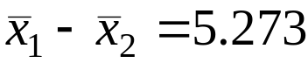mm. A 90% confidence interval for uses the critical value t*=1.729 from the t(19) distribution. The interval is

=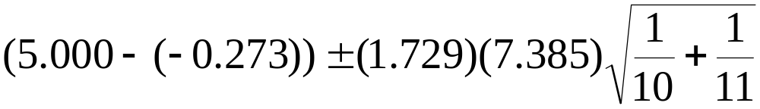

= 5.273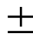5.579

We are 90% confident that the difference in means is in the interval (-0.306, 10.852). The calcium treatment reduced blood pressure by about 5.3mm more than a placebo on the average, but the margin of error for this estimate is 5.6mm.

